Eurographics Symposium on Rendering 2018

T. Hachisuka and W. Jakob (Guest Editors)

*Volume 37* (*2018*), *Number 4*

**Deep Adaptive Sampling for Low Sample Count Rendering**

Alexandr Kuznetsov Nima Khademi Kalantari Ravi Ramamoorthi

University of California, San Diego

4 spp Input

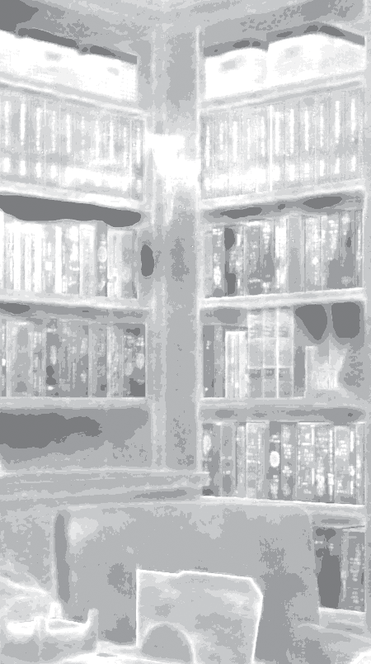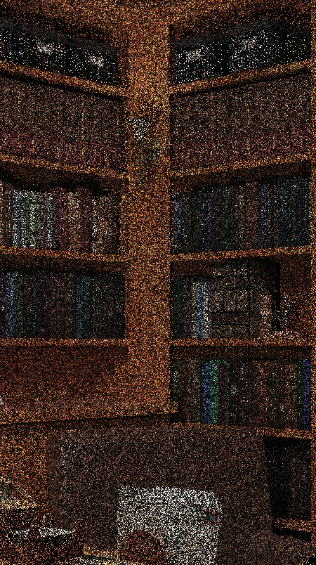

High Sampling Low Sampling

|  |  |  |  |  |
| --- | --- | --- | --- | --- |
|  |  |  |  |  |
|  |  |  |  |
|  | | | |

9.06×10-3

6.74×10-3 rMSE errors

1 spp Input (Uniform) Our Sampling Map

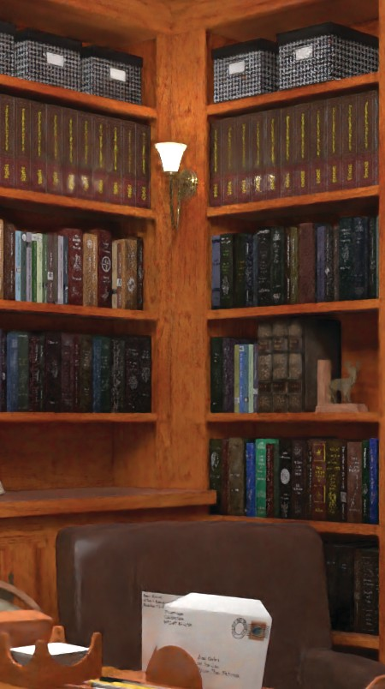

(Adaptive)

Uniform

Ours

Ground Truth

Our Result

**Figure 1:** *We propose a deep learning approach for joint adaptive sampling and reconstruction of Monte Carlo (MC) rendered images. Using a convolutional neural network (CNN), we ﬁrst estimate a sampling map from a 1 sample per pixel (spp) MC rendered input (shown on the left). In the sampling map, brighter areas indicate more adaptive samples. We then use the map to distribute three additional samples per pixel on average and denoise the resulting 4 spp render using another CNN to obtain our ﬁnal image. We train both networks in an end-to-end fashion, and thus, our sampling map network distributes more samples to the areas that are challenging for the denoiser. For example, the top (green) inset shows an area which is challenging for the denoiser. Our approach throws more samples in this region, and thus, we are able to produce results with higher quality than uniform sampling. On the other hand, the denoiser can easily remove the noise from the envelope in the bottom (red) inset using the provided auxiliary buffers, such as shading normals and textures. Therefore, our approach does not waste the sampling budget for this area. The releative mean squared errors (rMSE), listed below the insets, are computed on the entire images. See Fig. 7 for comparison against several other approaches on a variety of scenes.*

## Abstract

*Recently, deep learning approaches have proven successful at removing noise from Monte Carlo (MC) rendered images at extremely low sampling rates, e.g., 1-4 samples per pixel (spp). While these methods provide dramatic speedups, they operate on uniformly sampled MC rendered images. However, the full promise of low sample counts requires both adaptive sampling and reconstruction/denoising. Unfortunately, the traditional adaptive sampling techniques fail to handle the cases with low sampling rates, since there is insufﬁcient information to reliably calculate their required features, such as variance and contrast. In this paper, we address this issue by proposing a deep learning approach for joint adaptive sampling and reconstruction of MC rendered images with extremely low sample count*

|  |  |  |
| --- | --- | --- |
|  | *s. Our system consists of two convolutional neural networks (CNN),* | |
| *responsible for estimating the sampling map and denoising, separated by a renderer. Speciﬁcally, we ﬁrst render a scene with* | | |
| *one spp and then use the ﬁrst CNN to estimate a sampling map, which is used to distribute three additional samples per pixel* | | |
| *on average adaptively. We then ﬁlter the resulting render with the second CNN to produce the ﬁnal denoised image.* | |  |

*We train both networks by minimizing the error between the denoised and ground truth images on a set of training scenes. To use backpropagation for training both networks, we propose an approach to effectively compute the gradient of the renderer. We demonstrate that our approach produces better results compared to other sampling techniques. On average, our 4 spp renders are comparable to 6 spp from uniform sampling with deep learning-based denoising. Therefore, 50% more uniformly distributed samples are required to achieve equal quality without adaptive sampling.*

## CCS Concepts

* ***Computing methodologies*** *→* ***Ray tracing;*** *Neural networks; Image processing;*

§c 2018 The Author(s)

Computer Graphics Forum §c 2018 The Eurographics Association and John Wiley & Sons Ltd. Published by John Wiley & Sons Ltd.

## Introduction

Monte Carlo (MC) path tracing [Kaj86] is a powerful and general technique for physically-based rendering, but requires evaluating a large number of samples to produce noise-free images, resulting in lengthy render times. This problem has been the subject of exten- sive study and many approaches have been developed to quickly render a noisy image at reduced sampling rates and remove the noise in a post-process [ZJL∗15]. As a result, MC rendering has now become standard for ofﬂine rendering [KFF∗15].

However, with the rise of virtual and augmented reality sys- tems and the recent interest of gaming companies in real-time ray tracing, generating noise-free results from input images with *extremely* low sampling rates (e.g., 4 samples per pixel) is be- coming an important research topic. The most recent ﬁltering ap- proaches [CKS∗17, SKW∗17] have focused on this problem and are able to generate high-quality results from input images with 1-4 samples per pixel (spp). These advances have led to dra- matic speedups, bringing computation times from hours or days to seconds or even real-time frame rates, often limited only by the speed of the base path tracer. Indeed, deep-learning based denois- ing [CKS∗17] is integrated into NVIDIA’s latest Optix5 GPU real- time raytracer.

The major drawback of these approaches is that they only fo- cus on the ﬁltering problem and use uniformly sampled images as the input. However, previous techniques [Mit87, Mit91, Guo98, HJW∗08, ODR09, SSD∗09, ETH∗09, RKZ11, LWC12, RMZ13]

have demonstrated that the quality of the output images can be signiﬁcantly improved through adaptive sampling. These methods dedicate a portion of the total sampling budget to render an ini- tial image by uniformly distributing the samples. They then com- pute the variance, coherence maps [Guo98], or frequency con-

tent [ETH∗09], to estimate a sampling map to adaptively dis-

tribute the rest of the samples. Unfortunately, these approaches typically require the initial uniformly sampled image to be ren- dered with a reasonably large number of samples. Therefore, they fail to properly estimate a sampling map when the initial im- age is rendered with extremely low sample counts (1 spp in our case). This is the main reason that the most recent ﬁltering tech- niques [CKS∗17, SKW∗17] only use uniformly sampled images as the input.

In this paper, we address this challenge by using deep learning for *both* the adaptive sampling and ﬁltering/reconstruction stages.

|  |  |  |  |
| --- | --- | --- | --- |
| We ﬁrst render a uniformly sampled image with 1 spp, which is | | | |
| then used along with several auxiliary buffers, such as shading nor- | | | |
| mals and texture, as the input to a convolutional neural network | | | |
| (CNN) to estimate a sampling map (see Fig. 2). | | | We then use the |
| map to adaptively distribute three additional samples and generate | | | |
| an image with an average of 4 spp. Finally, the 4 spp image along | | | |
| with other auxiliary buffers are passed to another CNN to produce | | | |
| the ﬁnal denoised image. We train both networks in an end-to-end | | | |
| fashion by minimizing the error of the denoised and ground truth | | | |
| images on a wide range of scenes with | | a variety of distributed ef- | |
|  | such as depth of ﬁeld, global illumination, and motion blur. | | |

fects,

Speciﬁcally, our work makes the following contributions:

We propose the ﬁrst learning-based approach for adaptive sam- pling in MC rendering. We demonstrate better results than other

*•*

sampling techniques on general scenes with soft shadows, depth of ﬁeld, and global illumination (see Fig. 7). Overall,

results are comparable to 6 spp results with uniform sampling.

We thus take Monte Carlo rendering an important step closer to- wards low spp for interactive and rapid preview applications.

our 4 spp

Since training is done iteratively, online rendering to adaptively place the samples during training is impractical. We propose an efﬁcient approach for generating rendered images with arbitrary number of samples to make the training practical (Sec. 4.1).

*•*

We present a method for computing the gradient of the rendered images with respect to the sample counts, which is required for the end-to-end training (Sec. 4.2). As a result, our sampling map network learns to throw more samples in the areas that are difﬁ- cult for the denoiser to ﬁlter (Figs. 1, 8 and 9).

*•*

## Previous Work

There has been extensive research to address the Monte Carlo (MC) noise problem through adaptive sampling and reconstruction. A thorough review of all these approaches is beyond the scope of this paper. For brevity, here we only focus on the most relevant work and refer the readers to the review by Zwicker et al. [ZJL∗15].

Shortly after the introduction of MC rendering [CPC84], several approaches proposed to reduce the noise by distributing the sam- ples adaptively. These approaches [LRU85, Mit87, Mit91, BM98] use a speciﬁc metric (e.g., contrast or variance) to detect the prob- lematic areas and assign more samples to them. Hachisuka et al. [HJW∗08] propose to dedicate more samples to regions of high contrast in a multidimensional space. Overbeck et al. [ODR09] use a metric based on contrast and wavelet coefﬁcients to estimate the sampling map. Several approaches [SSD∗09, ETH∗09] propose to adaptively place the samples based on the frequency content of the image. Kalantari et al. [KS13] detect the noise at each pixel using mean absolute deviation and throw more samples in the noisy re- gions. However, these methods suffer from two main drawbacks. First, they typically require the initial image to be sampled with a reasonably large number of samples, and thus, produce unsatisfac- tory results in our cases with extremely low sample counts. Second, these approaches often have a reconstruction stage to remove noise from the rendered images. However, the adaptive sampling stage of these methods is independent of the reconstruction process, and thus, is not optimal.

To address the second issue, several approaches have proposed to perform joint adaptive sampling and reconstruction. These meth- ods use no-reference error estimation metrics to select the best pa- rameter for a ﬁlter and assign more samples to the regions with large error. Several algorithms estimate the reconstruction error by computing the bias and variance of a Gaussian [RKZ11], non- local means [RKZ12], local linear regression [MCY14], and poly- nomial [MMMG16] ﬁlters and use the error to adaptively sample the image in multiple stages. A few approaches use Stein unbiased risk estimator (SURE) as their no-reference error estimation met- ric [LWC12, RMZ13]. Bauszat et al. [BEEM15] proposes to recon- struct a dense error map from a set of sparse, but robust estimates. Finally, Moon et al. [MGYM15] propose an iterative and recursive error estimation technique to perform joint sampling and ﬁltering. The main drawback of these approaches is that they are not able to

reliably estimate the reconstruction error on images with low sam- pling rates.

Our method is inspired by the recent learning-based approaches for ﬁltering MC noise [KBS15, BVM∗17, CKS∗17]. Bauszat et al. [BEM11] distributes the samples based on the summation of ﬁlter weights. Kalantari et al. [KBS15] propose to use a neural net- work to set the parameters of a cross-bilateral or cross non-local means ﬁlter. Bako et al. [BVM∗17] extends this idea by replac- ing the entire pipeline with a deep convolutional neural network (CNN). Chaitanya et al. [CKS∗17] propose to remove MC noise using an encoder-decoder network and demonstrate high-quality results on rendered images with 1-4 samples per pixel. Within real- time rendering, we also build on many recent frequency-based pa- pers [MWR12, MYRD14], and particularly the approaches by Yan et al. [YMRD15] and Wu et al. [WYKR17]), which introduce de- noising for very low sampling rates (e.g., 4-9 spp). However, all of these methods only work on uniformly sampled images. In con- trast, we propose a deep learning approach to perform joint sam- pling and reconstruction on images with extremely low adaptive sampling rates.

Adaptive sampling at 4 spp, which requires estimating the sam- pling map from 1 spp images, has to our knowledge never been demonstrated previously. However, to make a fair comparison, we implement and compare to a few simple alternative algorithms in- cluding variance [LRU85] and SURE-based [LWC12] approaches. As discussed in Sec. 6, since computing the statistics in each pixel using only one sample is impossible, we compute them over a patch of size 4 4. We also compare against uniform sampling with equal rate (4 spp) and equal quality.

*×*

## Method

ples per pixel),

Given a ﬁxed budget of a small number of samples *n* (e.g., 4 sam-

the goal of our approach is to generate an image as close as possible to the ground truth image rendered with many samples. We achieve this goal by ﬁrst effectively distributing the samples to render a noisy image and then removing the noise to pro- duce a high-quality image. The overview of our approach is given in Fig. 2. In the following sections, we describe our sampling map estimator and denoiser.

## Sampling Map Estimator

We propose to model the sampling map estimation process using a convolutional neural network (CNN). In this case, the CNN takes

the 1 spp noisy image as well as several auxiliary features as the

Speciﬁ- cally, the CNN’s input consists of the noisy image in RGB format (3 channels), textures in RGB format (3 channels), shading normals (3 channels), depth (one channel), and direct illumination visibility (one channel).

input (11 channels) to produce a single channel output.

We use the output of the network to generate the ﬁnal sampling map, which is used for distributing the additional three samples per pixel. Therefore, the average of the ﬁnal sampling map for all the pixels should be close to the remaining sampling budget, i.e., 3 spp. To enforce this, we compute the ﬁnal sampling map, *s* from the output of the network, *x*, using the following normalization process:

(1)

where *s*(*p*) refers to the sampling map at pixel *p*, *M* is the number of pixels in the image, and *n* is the remaining sampling budget (3 in our case). Note that, the exponential terms make the network’s output, which is in the range ( *,* ), positive. Here, the ﬁrst two terms basically normalize the network’s output to have an average of one, and the last term enforces the sampling map to have an aver- age of *n* spp. Finally, the round operator ensures that the sampling map at each pixel has an integer value.

*s*(*p*)= round.

*M*

∑*M*

*j*=1

*ex*( *j*)

*× ex*(*p*) *× n*Σ *,*

*−∞ ∞*

|  |  |  |  |
| --- | --- | --- | --- |
|  | The sampling map, *s* is then used by the renderer to adaptively | | |
| distribute the three additional samples per pixel and produce an im- | | | |
| age with an average of 4 spp (including the initial 1 spp). | | | This im- |
| age is then used as the input to the next stage (denoiser) to produce | | | |
| the ﬁnal denoised image | |  | |

.

As shown in Fig. 3, we use an encoder-decoder architecture sim- ilar to the one used by Chaitanya et al. [CKS∗17] for denoising. Intuitively, the sampling map network needs to estimate the qual- ity of the results after denoising and dedicate more samples to the problematic areas. Therefore, we use the same network architecture for the sampling map and denoiser networks.

The encoder and decoder in our network each have a total of 5 units, and we have a bottleneck unit in between them. Each encoder unit consists of two convolutional layers with kernel size of 3 3, followed by a 2 2 max pooling layer. The decoder units consist of an upsampling layer, followed by 2 convolutional layers with kernel size of 3 3. Since our system works on single images, we remove the recurrent connections from Chaitanya et al.’s network, which were used to handle sequences of images. Therefore, each unit in both the encoder and decoder contains two convolutional layers instead of three. Moreover, following Chaitanya et al. we use skip connections between the convolutional layers in the encoder and decoder to help the network produce sharper sampling maps.

*×*

*×*

*×*

## Denoiser

The goal of the denoiser is to take the adaptively rendered image from the previous stage and produce a high-quality image compara- ble to the ground truth. We propose to use a CNN, shown in Fig. 3, to model the denoising process.

Our CNN takes the noisy rendered

image with an average of 4 spp (3 channels) as well as the auxiliary

features (8 channels), and produces the output image (3 channels).

Note that, Chaitanya et al. [CKS∗17] separate the texture from illumination and use a CNN to only denoise the illumination image. Therefore, their system is not able to handle scenes with distributed effects, like depth of ﬁeld and motion blur, since they contaminate the texture with noise. In our system, we use the CNN to directly denoise the noisy rendered image, and thus, are able to handle gen- eral distributed effects (see Fig. 7).

## Training

As discussed, we propose to train both the sampling map estima- tor and the denoiser networks by minimizing the error between the

# 

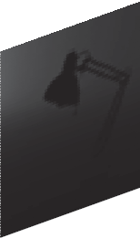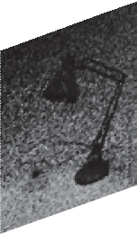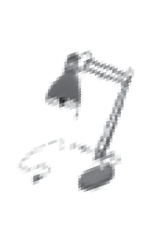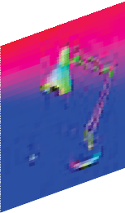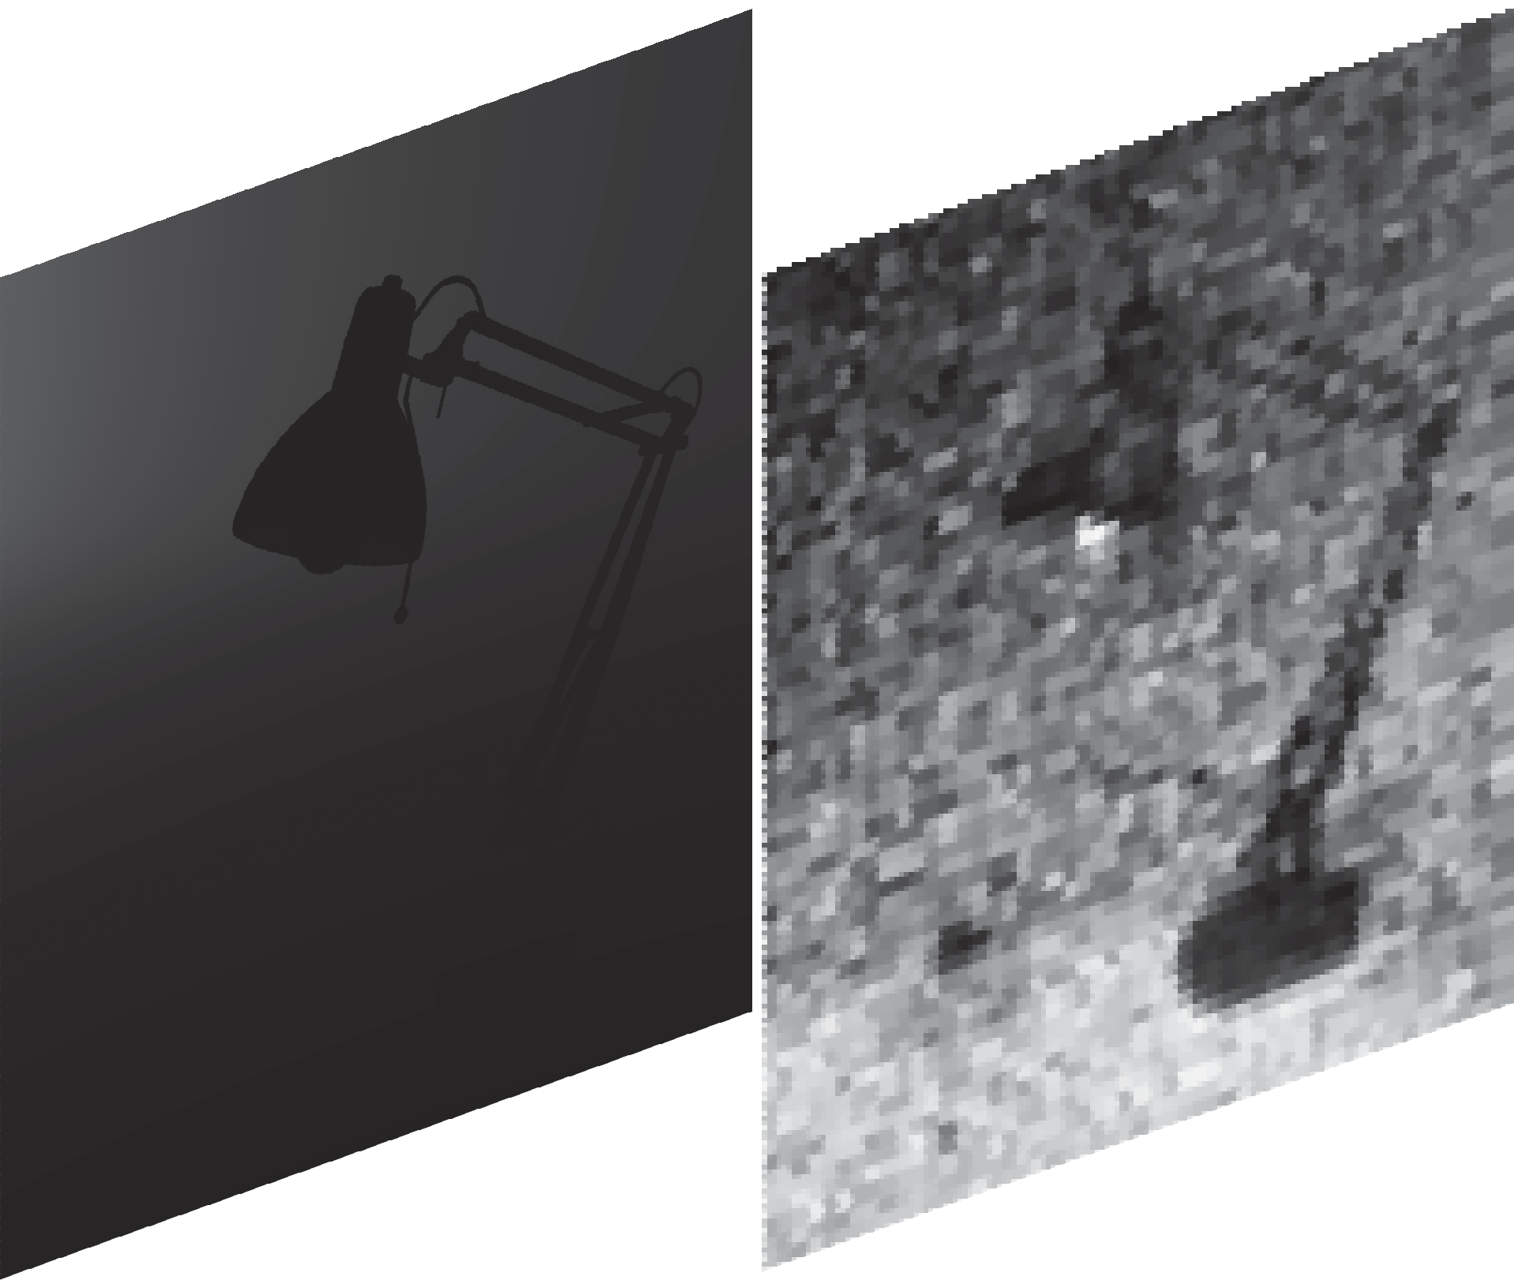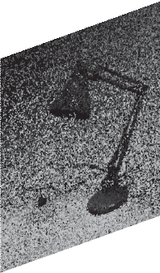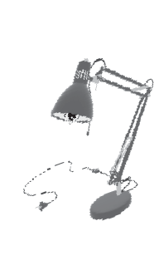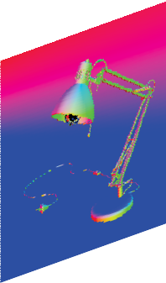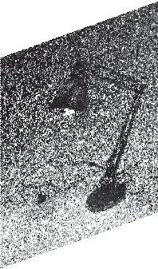

Sampling Map Estimator

Initial Uniformly Sampled Image (1 spp)

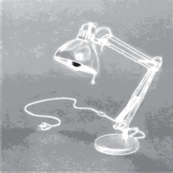

Sampling Map

Adaptively Sampled Image (4 spp)

Final Image

**Figure 2:** *In our system, we ﬁrst render a scene with one spp and use it to calculate the sampling map. Then, we use the sampling map to render three additional samples. Finally, we denoise the resulting rendered image with an average of 4 spp to obtain the ﬁnal denoised image.*

Denoiser

Renderer

32 43 57 76 101 101

76 57 43 32 64 n

rendered images to generate an image with higher sampling counts. For example, we can combine two independently rendered images with 3 and 4 spp to produce an image with 7 spp as:

*I* = 3 *I*3 + 4 *I*4 *,*

7

7

Output

where *Is* is the rendered image with *s* samples per pixel. Therefore,

we propose to pre-render a set of images with power of two sam-

pling rates, *I*20 *, I*21 *,··· , I*2*k* , where 2*k* is a large number (1024 and

3x3 Convolution Max Pooling Upsampling

more).

Input

We then produce images with any number of samples by combining the appropriate images in the set as follows:

**Figure 3:** *We use an encoder-decoder architecture for both the sampling map and denoiser networks. Our network contains 5 en-*

*Is* =

*k i*=0

2*i I*2*i g*(*s,* 2*i*)

*s ,* (2)

*coder and decoder units, separated by a bottleneck unit. Each en- coder consists of two convolutional layers followed by a max pool- ing layer, while the decoder units consist of an upsampling layer followed by two convolutional layers. All the convolutional lay- ers have a kernel size of* 3 3*. We use skip connections between the convolutional layers in the encoder and decoder units. We use ReLU activation function after all the convolutional layers except the last one. Note that, the output of the sampling map network has one channel, while the denoiser’s output has three channels.*

∑

*×*

denoised and ground truth images in an end-to-end fashion. In our system, the renderer is in between the two CNNs, and thus, we need

to overcome two major challenges to effectively train the networks.

a large number of iterations are required for the system to converge during training. At every iteration, we need to render ad- ditional samples based on the estimated sampling map from the ﬁrst stage, which makes the training impractical as rendering is com- putationally expensive. Second, to train the sampling map network using backpropagation, we need to differentiate the renderer, which is not straightforward. Next, we discuss our proposed approach for addressing these two issues as well as the optimization process.

First,

## Render Simulator

A simple way to address the computational complexity of the ren- dering process is t

o pre-render a set images at different sampling

We can then choose the

rates, *I*1*,··· , IN* , where *N* is a large number.

where *Is* is the image with the desired sampling rate and *I*2*i* is the

pre-rendered image with 2*i* samples. Here, *g*(*s,* 2*i*) is a binary value of 0 or 1 according to whether the binary representation of *s* in- cludes the term 2*i*. Note that, since the sampling map has different values at each pixel, we evaluate this expression separately for each pixel, but in this equation we omit the pixel notation for simplicity. For each render at a given sampling rate, there is an inﬁnite num- ber of noise patterns. Therefore, to make our network more robust to noise, we render multiple alternative images with different seeds and pick one at runtime for each power of two sampling rate.

An alternative approach is to render a large number of 1 spp im- ages and then generate an image with arbitrary number of samples, *n*, by combining *n* 1 spp images. Although this approach is more efﬁcient than our proposed power of two pre-rendering method, it requires a signiﬁcant amount of storage to store the 1 spp rendered images as well as the auxiliary buffers. Our method provides a rea- sonable trade-off between storage and computational complexity.

## Gradient of the Renderer

In order to train the networks in an end-to-end fashion, we need to differentiate the renderer, i.e., compute the gradient of the rendered image with respect to the sampling map at each pixel. Unfortu- nately, the renderer is a complex system and there is not a straight- forward way to calculate the gradient analytically. Therefore, we propose to compute the gradient numerically as follows:

appropriate image for each pixel based on the estimated sampling map during training. However, this approach requires a signiﬁcant amount of computational power and storage for rendering and sav-

∂*Is*

∂*s* =

*Is*+*h −Is ,* where *Is*+*h* =

*s Is* + *h Ih ,* (3)

*s* + *h*

ing the images as well as the auxiliary buffers at all the sampling rates.

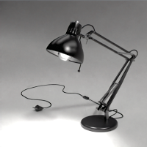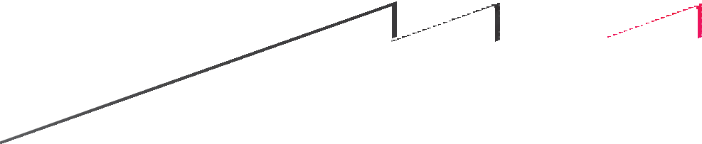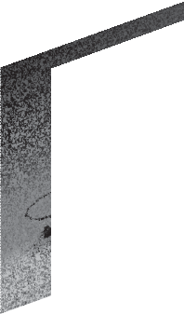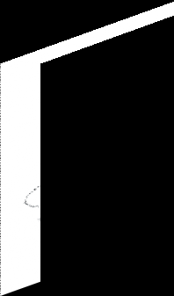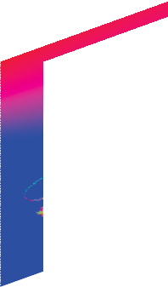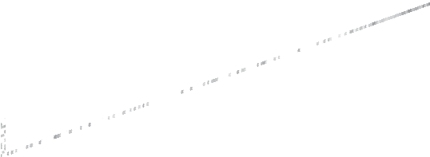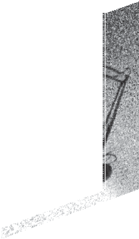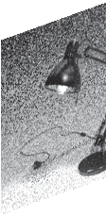

*h*

Our main observation is that we can combine two independently

where *h* is the additional samples (e.g., 1 or 2), used for the numeri- cal differentiation. Here, *Is*+*h* is obtained using Eq. 2 from the orig- inal image with *s* spp, *Is*, and the image rendered with additional

*h* spp, *Ih*. Unfortunately, since the rendering process is stochastic, this gradient is extremely noisy and makes the training unstable.

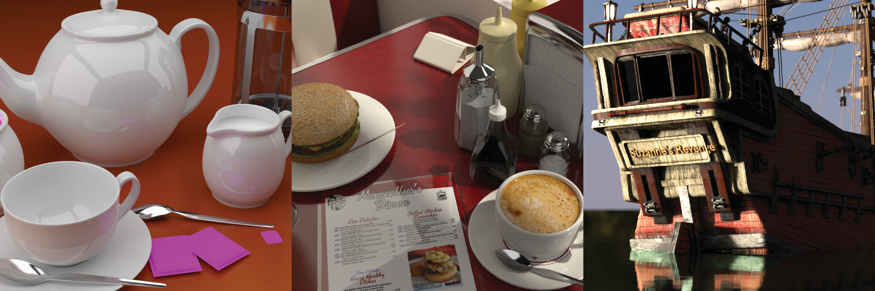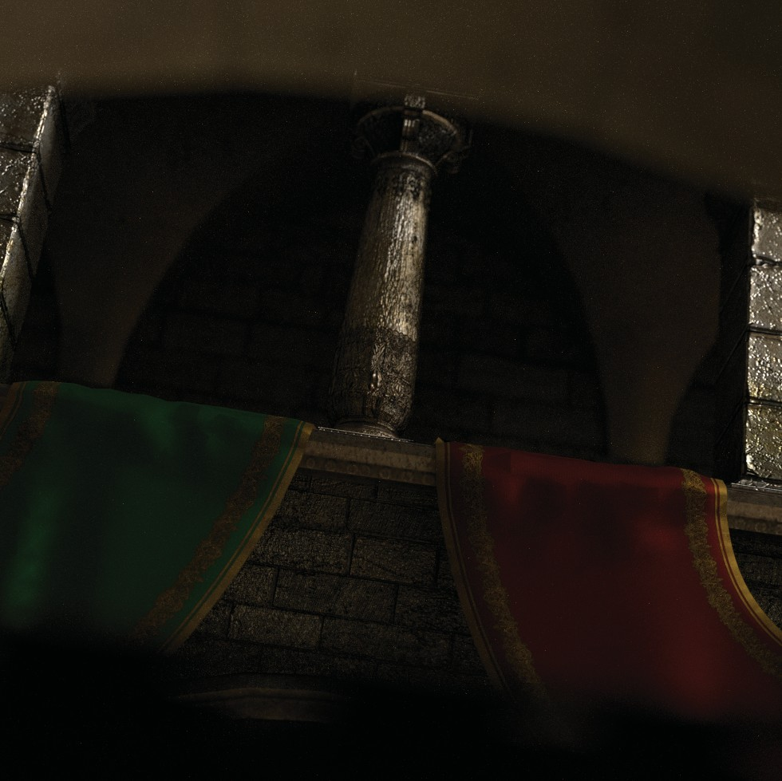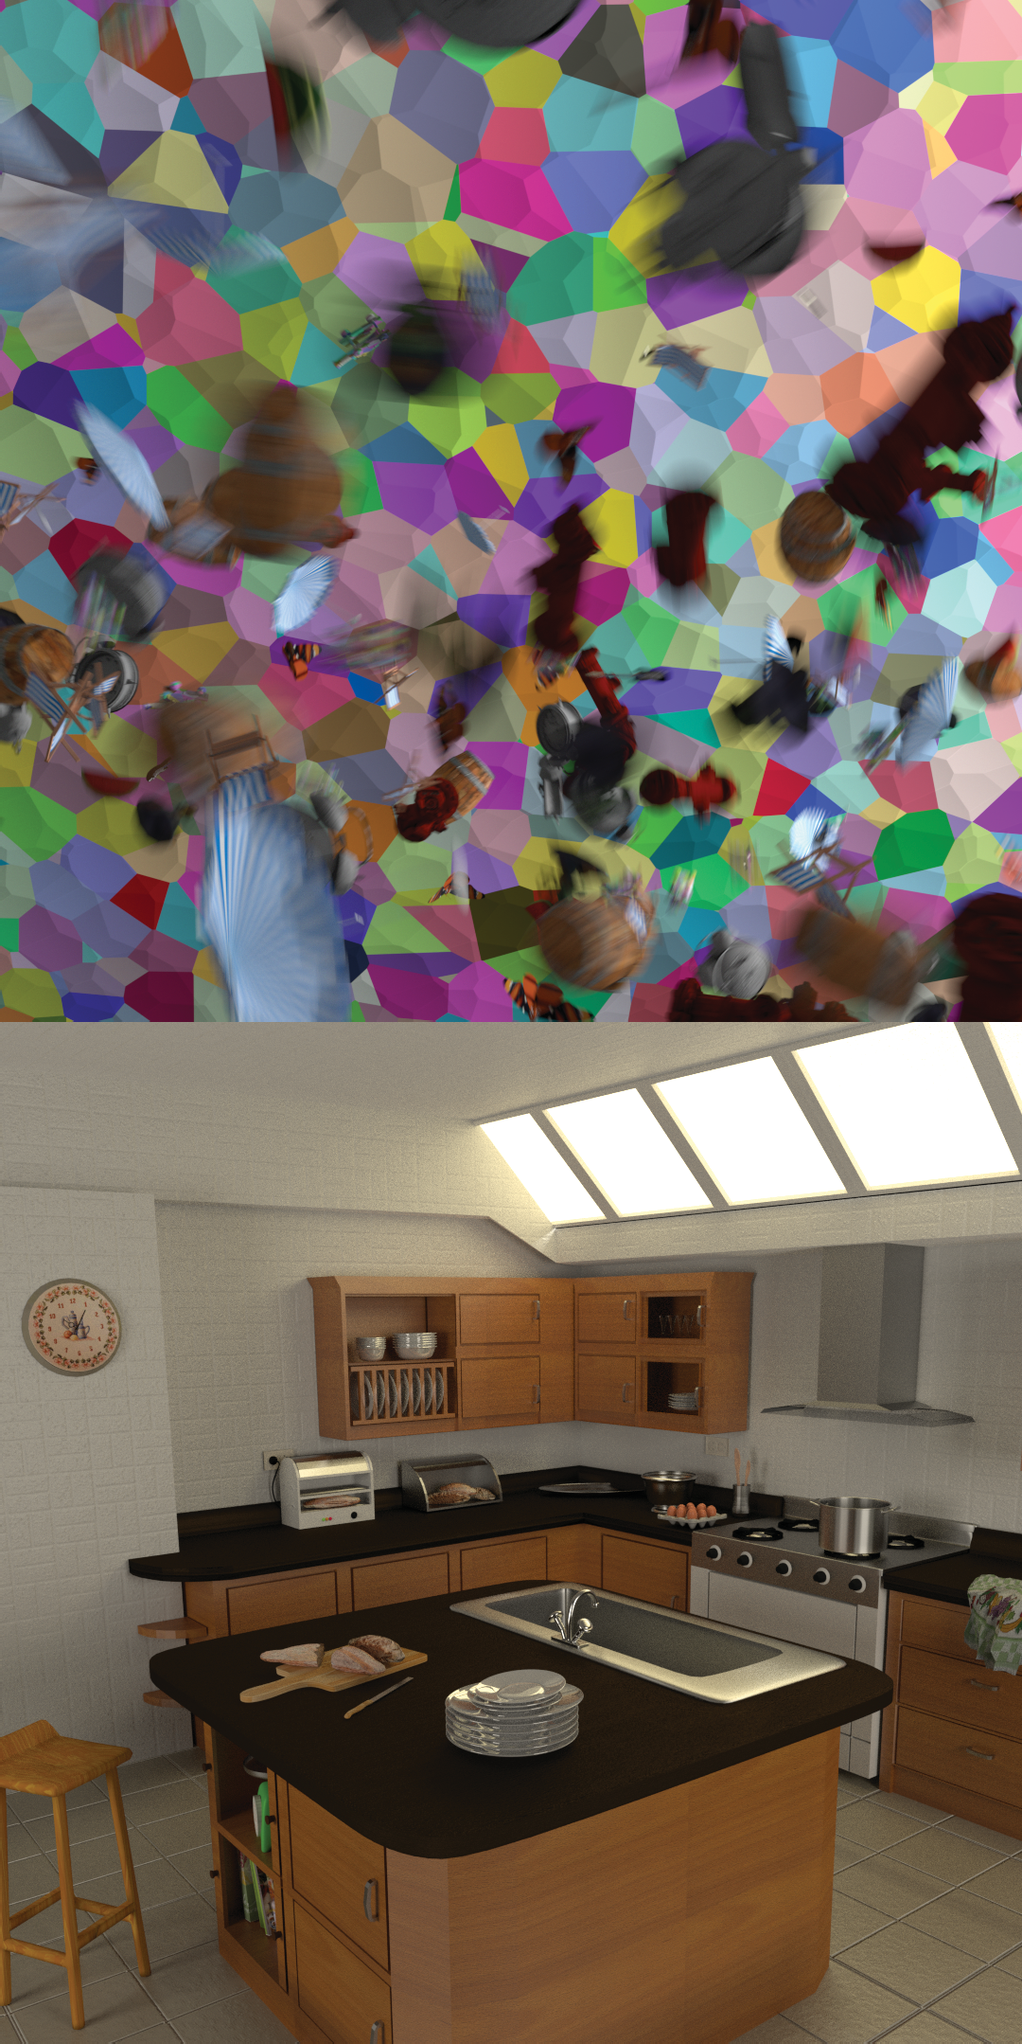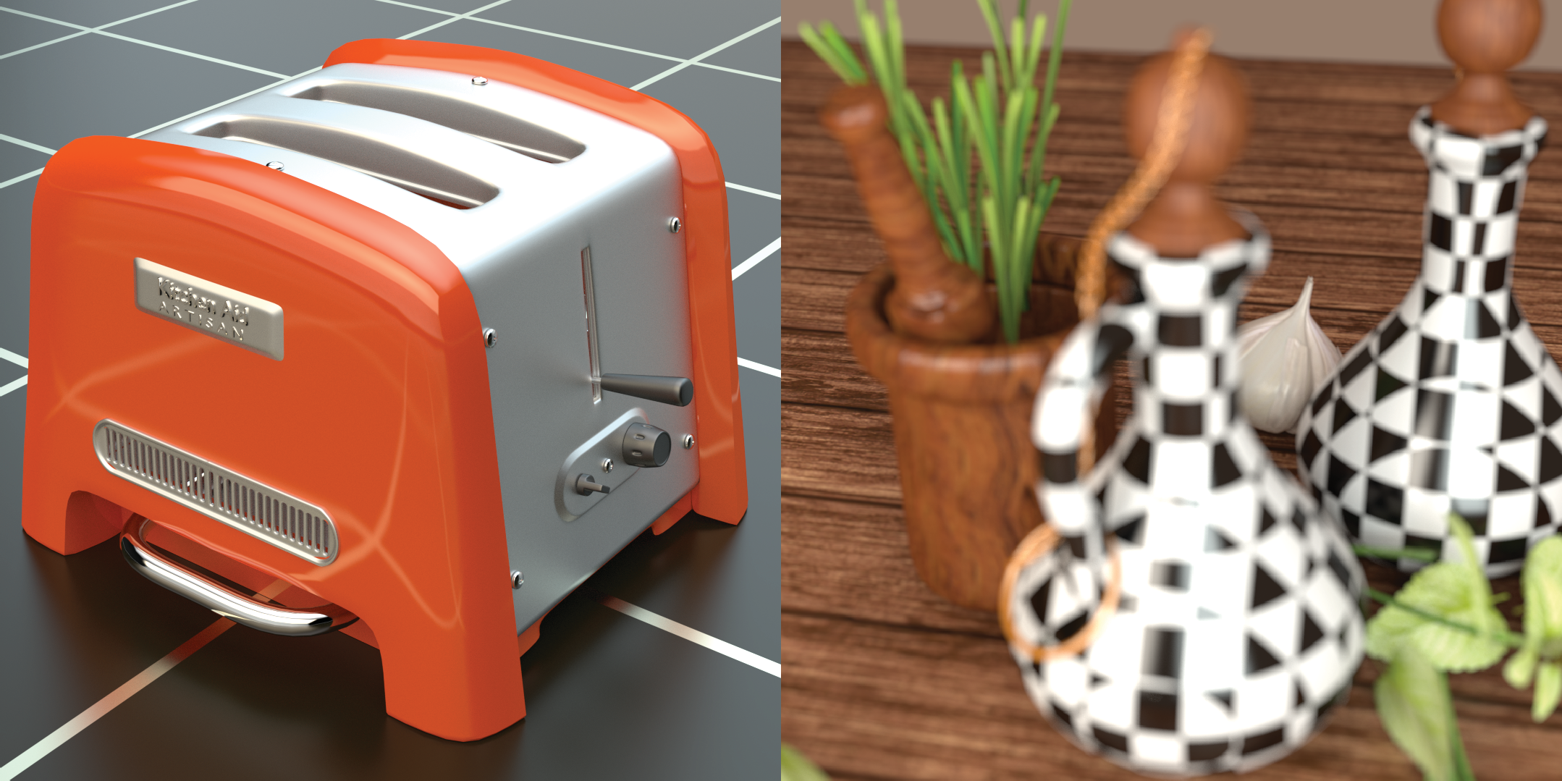

|  |  |  |  |
| --- | --- | --- | --- |
|  |  |  |  |
|  |  |  |  |

One way to address this problem is to compute the gradient over a large number of independently rendered *h* spp images as follows:

∂*Is*

∂*s*

*N Ii*+*h −Is*

*i s Is* + *h Ii*

= ∑

*i*=1

+

*s hN ,* where *Is*+*h* =

*s h h ,* (4)

where *N* is a large number to ensure the gradients are noise-free. However, this approach requires pre-rendering a large number of images with *h* spp, which is computationally expensive and re- quires signiﬁcant amount of storage. To address this issue, we sim- plify Eq. 4 as follows:

**Figure 4:** *A subset of the scenes in our training set containing a*

∂*Is*

∂*s*

*N s Is* + *h Ii −* (*s* + *h*) *Is*

*variety of distributed effects, such as global illumination, glossy*

= ∑

*i*=1

*h*

*hN* (*s* + *h*)

*.* (5)

*reﬂections, motion blur, and depth of ﬁeld.*

Here, we have replaced *Ii* with its deﬁnition in Eq. 4 and per- formed basic simpliﬁcations. Next, we apply the summation to each term in the numerator as follows:

*s*+*h*

*i*= *h i*=

data contains a wide range of images with a variety of distributed effects, such as depth of ﬁeld, glossy reﬂections, motion blur, and global illumination.

∂*Is*

∂*s* =

∑*N* 1 *Ii /N −* ∑*N* 1 *Is/N s* + *h*

*.* (6)

We render the ground truth images with at least 1024 spp to ob- tain noise-free images. For inputs, we render a set of images with

Here, the ﬁrst term in the numerator is the average of a large number of independently rendered images with *h* spp, and thus, in the limit (*N* ), becomes the ground truth image *I*∞.† Since *Is* is

*→ ∞*

independent of *i*, the second term can be simpliﬁed to *Is*. Therefore, we have:

∂*Is* = *I*∞ *−Is .* (7)

∂*s s* + *h*

As is typical in numerical differentiation, we set *h* equal to zero to obtain the ﬁnal gradient:

*.*

*I*∞ *−Is*

∂*s* = *s*

∂*Is*

(8)

Note that, while setting *h* to zero is not physically possible (cor- responds to no rendered image), we do this to ensure the gradient is independent of this parameter. As can be seen, the gradient is di- rectly proportional to the distance of the ground truth and current image. Moreover, it is inversely proportional to the current sam- pling rate *s*. This is intuitive, since as the sampling rate increases, adding more samples does not signiﬁcantly affect the pixel color. The ﬁnal gradient in Eq. 8 is smooth and we can use it to effectively train both networks in an end-to-end fashion.

## Implementation Details

In this section, we discuss the implementation details required for reproducing our results. Our implementation is available at: http:

//cseweb.ucsd.edu/~viscomp/projects/dasr/.

*Dataset –* Our training data consists of a set of 700 input and ground truth images from 50 scenes, where each scene is rendered from 2 to 30 different viewpoints. As shown in Fig. 4, our training

*†* While the ground truth image is theoretically obtained by rendering the scene with an inﬁnite number of samples, in practice we consider the im- ages rendered with a large but ﬁnite number of samples (e.g., 1024 spp) as ground truth.

power of two sampling counts to be able to efﬁciently produce im- ages with arbitrary sampling rates during training (Sec. 4). More- over, by rendering multiple alternative images for the same power of two sampling count, we get more noise patterns.

Since the range of color and depth values are large, we compress their range using a logarithmic function before using them as the input to our system, i.e., log(1 + *z*), where *z* is the pixel values of the color or depth. For the other auxiliary buffers, we perform standard normalization by computing the mean and standard deviation over the entire training set.

*Training Details –* Since we have two networks in our system, performing the training in a single stage is challenging. To reduce the complexity of the training process, we propose to perform it in three stages. In the ﬁrst stage, we train the denoiser network on a set of noisy inputs and their corresponding ground truth images. To ensure the network is able to handle adaptively sampled images, we use randomly generated sampling maps to produce adaptively sam- pled input images with an average of 4 spp. Moreover, we generate the sampling maps randomly at lower resolution and obtain the ﬁ- nal map using 8x upsampling to ensure smoothness. In the second stage, we use the denoiser network from the previous stage and only train our sampling map network until convergence. Finally, in the third stage, we ﬁne tune both networks by alternating between training the sampling map and denoiser networks at every iteration.

As is common with the deep learning approaches, we break down the images into patches of size 512 512. For training, we use Adam solver [KB14] with the default parameters and a learn- ing rate of 0.0001. We train our system using mini-batches of size 6 as we found they provide the best trade-off between the speed and convergence. In our system, the training in the ﬁrst, second, and third stages converge after 25000, 5000, and 40000 iterations, respectively.

*×*

*Loss –* In order to measure the error between the denoised and ground truth images during training, we use the following loss con- sisting of spatial and gradient terms:

# 

|  |  |  |  |  |
| --- | --- | --- | --- | --- |
|  | Variance | SURE | Uniform | Ours |
| rMSE | 9.95 | 8.86 | 7.50 | 6.26 |

|  |  |  |  |
| --- | --- | --- | --- |
|  | SURE - 1 spp | SURE - 2 spp | SURE - 3 spp |
| rMSE | 8.86 | 8.32 | 8.08 |

**Table 1:** *Comparison of our approach against other methods in terms of relative mean squared error (rMSE). We factor out* 10−3 *from all the reported values for clarity. The rMSE values are av- eraged over 60 test images. For equal quality, we obtain an rMSE of* 5*.*92 10−3*, which is slightly lower than ours since we are only able to render images with an integer number of samples.*

*×*

*L* = 0*.*5*Ls* + 0*.*5*Lg* (9)

where *s* and *g* refer to the spatial and gradient terms, respec- tively. For the spatial loss, we use relative *A*1 as it properly models the human vision sensitivity to noise in the dark regions:

*L L*

**Table 2:** *Comparison of SURE method with different initial sam- pling counts in terms of relative mean squared error (rMSE). We factor out* 10−3 *from all the reported values for clarity. The rMSE values are averaged over 60 test images.*

of the denoiser is optimized for the particular sampling strategy. Moreover, note that there is a long tail in the EQ distribution, which indicates that our adaptive sampling strategy enables robustness with large gains where possible, and more modest but still signiﬁ- cant beneﬁts in the common case.

*Error Comparison –* We show the average relative mean squared error (rMSE) of all the approaches on a set of 60 test scenes in Ta-

*Ls*(*c*ˆ*, c*)= *"c*ˆ*− c"*1

*|c|* + ε

(10)

ble 1. Our test scenes contain a variety of effects such as global illumination, motion blur, and glossy reﬂections and none of the

where ε = 0*.*01 and *c*ˆ and *c* are the denoised and ground truth im- ages, respectively. For the gradient term, we use a slightly modiﬁed version of the high frequency error norm (HFEN) [RB11] to ensure the edges in the ﬁnal image are sharp. Speciﬁcally, our gradient term is deﬁned as:

test scenes are included in our training set. Although we optimize our approach using a different error function (Eq. 9), we still pro- duce better results than other approaches in terms of rMSE, which demonstrates the generality of our system. It is worth noting that other adaptive sampling approaches perform poorly even compared

to uniform sampling. This is mainly because 1 spp input images do

*Lg*(*c*ˆ*, c*)= *"g*(*c*ˆ) *−g*(*c*)*"*1

*|c|* + ε

(11)

not provide sufﬁcient information for these approaches to reliably estimate their required statistics, and thus, their estimated sampling

where *g*(*c*ˆ) is the Laplacian of Gaussian operator. Comparing to the

original HFEN, we introduce the division by *c* + ε to better model the human vision system’s sensitivity to variations in the dark ar- eas. Note that, since the range of color values can be signiﬁcantly large, we apply a logarithmic function to the ground truth image to compress its range before computing the loss, i.e., *c* = log(1 + *c*˜), where *c*˜ is the ground truth image in the linear domain.

*| |*

## Results

We implemented our approach in PyTorch [PGC∗17] and com- pared against several other sampling techniques including adap- tive sampling using variance [LRU85] and SURE [LWC12] met- rics, as well as uniform sampling. Note that, adaptive sampling for extremely low sampling rates has not been demonstrated before. Since computing the variance of each pixel using one sample is im- possible, we calculate it in a 4 4 patch to ensure we have sufﬁcient samples. We use the same strategy to compute the required variance for the SURE-based sampling map. Moreover, we implemented the SURE-based approach using both the cross-bilateral ﬁlter, as used in the original paper, and our denoiser network. However, we only show their results using the cross-bilateral ﬁlter as we found it pro- duces better results. The SURE’s sampling map is noisy, so we ap- ply another cross-bilateral ﬁlter to smooth it out. Note that, the cross-bilateral ﬁlters are only used to generate the sampling map to render the additional samples and they are not used for the ﬁnal denoising.

*×*

We also perform equal quality (EQ) uniform sampling compar- ison. In all cases, we used our denoiser network to remove noise from the rendered images with different approaches. We use each approach to generate adaptively sampled input images on our train- ing set and retrain the denoiser network to ensure the performance

maps are usually noisy and inaccurate (see Figs. 8 and 9).

Note that, as discussed, we compute the variances for the SURE method in a 4 4 patch on the 1 spp input images. We also ex- perimented with an alternative sampling strategy, where we use 2 or 3 spp input images to be able to directly compute the variances in each pixel. As shown in Table 2, the results of the SURE ap- proach improve as the initial sampling rate increases. This is ex- pected, since by increasing the initial uniform sampling rate, we decrease the budget for adaptive sampling. Therefore, SURE’s re- sults converge to the result of uniform sampling. However, in our main comparison, we start from 1 spp input images for all the ap- proaches to have a fair comparison.

*×*

Moreover, we show the rMSE error of all the approaches, rela- tive to ours, for our 60 test scenes in Fig. 5. Our approach produces better results than all the other approaches on all but two scenes where our error is slightly worse than uniform sampling. We also show the histogram of required sampling rates for the equal qual- ity comparison over all the 60 images in Fig. 6. To achieve similar error to our method using uniform sampling (EQ), on average, we need to increase the sampling rate to 6.12 spp. Therefore, with uni- form sampling we require 50% more than our adaptive sampling approach to achieve the same equality, which is a signiﬁcant im- provement.

*Representative Scenes –* We show the results of all the ap- proaches for six representative scenes (see Fig. 5) from our test dataset visually (Figs. 1 and 7) and numerically (Table 3). For each scene, we show two insets with high and low sampling densities to demonstrate the effectiveness of our approach. In general, our method produces signiﬁcantly better results in the top green insets with high adaptive sampling rate, while performing as well as other approaches in regions with low adaptive sampling rate shown in the

# 



**Figure 5:** *We show the rMSE error of all the approaches relative to ours for the 60 test scenes. Our method produces better results than all the other algorithms on almost all the scenes. The six scenes, shown in Fig. 7, are indicated on this plot.*

Sample Count for Uniform Equal Quality

|  |  |  |  |  |  |
| --- | --- | --- | --- | --- | --- |
| ID | Name | Var. | SURE | Unif. | Ours |
| 36 | LIBRARY | 9.73 | 7.99 | 9.06 | **6.74** |
| 29 | DINING | 4.16 | 4.32 | 3.34 | **2.21** |
| 21 | STAIRWAY | 8.70 | 7.94 | 7.39 | **6.95** |
| 15 | SPACESHIP | 2.13 | 1.55 | 1.94 | **1.19** |
| 48 | MONKEY HEAD | 0.37 | 0.37 | 0.31 | **0.17** |
| 58 | PLANTS | 0.75 | 1.44 | 0.47 | **0.44** |

30

25

20

15

10

5

0

4 5 6 7 8 9 10 11 12 13 14 15 16 17 18

spp

**Figure 6:** *We show the histogram of required sampling rate to achieve equal quality on all the 60 test scenes. The average of the required sampling rates are 6.12.*

red bottom insets. The DINING scene contains glasses with com- plex reﬂections and refractions. As shown in the green top inset, our approach correctly throws more samples in this area and is able to produce high-quality results. However, other approaches under- sample this difﬁcult region, and thus, their results contain residual noise. On the other hand, the noise on the cup in the red bottom inset can be easily removed by our denoiser. Therefore, despite having low sampling density in this area, we are able to produce comparable results to other techniques.

Next, we examine the STAIRWAY scene with global illumination. The highlights on the chandelier are difﬁcult to capture, and thus, our approach assigns more samples to this region. As a result, our method produces an image with higher quality than the other ap- proaches. However, the denoiser can effectively remove the noise in the red bottom inset, while preserving the sharp features by utiliz- ing the auxiliary buffers like textures. Therefore, all the approaches produce high-quality results in this area.

The SPACESHIP scene is particularly challenging, since the aux- iliary buffers do not contain any features for the visible objects be- hind the transparent glass. Our sampling map network assigns a signiﬁcant number of samples to this challenging area, and thus, our method produces a better result than the other approaches. Note the missing sharp line in variance and uniform, as well as the blotchiness in SURE’s results. The MONKEY HEAD is a scene with global illumination and motion blur. Other approaches pro- duce results with blotchiness in the motion blur area (green top inset) because of lack of sufﬁcient samples, while our method is able to dedicate the majority of samples to this region and produce a smooth result. On the other hand, the red bottom inset shows a re-

**Table 3:** *Quantitative comparison in terms of relative mean squared error (rMSE) for the six images in Figs. 1 and 7. For clar- ity, we factor out* 10−3 *from all the values.*

gion with low sampling density where all the approaches produce high-quality results.

The PLANTS scene demonstrates depth of ﬁeld and soft shadow effects. As a result, auxiliary buffers are also noisy, but the denoiser is still able to handle this. In this case, a simple blurring of the scene sufﬁces, and uniform sampling is adequate; our method provides only a moderate beneﬁt.

*Sampling Map –* Figure 8 shows comparison of our sampling map against other techniques on different scenes. The variance- based method focuses on noisy regions, like the table cloth in the DINING scene, despite it’s being very low frequency in the ground truth image. The SURE-based method misses some areas which are hard for the denoiser like the highlight on the lamp’s base in the LI- BRARY scene. Our method on the other hand, throws more samples in the areas which are hard for the denoiser like edges.

Figure 9 takes a closer look at the LIBRARY scene from Fig. 1. Here, the denoiser network has difﬁculty removing the noise from the green top inset, but can easily denoise the red bottom inset. The approach based on variance incorrectly throws more samples in the red inset, as it works independently of the denoiser. The SURE- based approach estimates the the error after ﬁltering, but the 1 spp input does not provide sufﬁcient information for this approach. Therefore, it is not able to properly sample the green inset, while at the same time wastes the sampling budget in the red inset. Our sampling map network produces a smooth map and is able to as- sign more samples to the problematic areas in the green inset, while dedicating fewer samples to the regions in the red inset. As shown, our method produces high-quality results in both cases, while other methods fail to handle the green inset.

*Timing –* Our method takes around 10 ms to evaluate the sam- pling map (5 ms) and denoiser (5 ms) networks on a machine with a GeForce GTX 1080 Ti GPU. This is a negligible overhead

Ours

Our Sampling Map

Our Input

EQ Uniform

Variance

SURE

Uniform

Ours

Ground Truth

High

# 

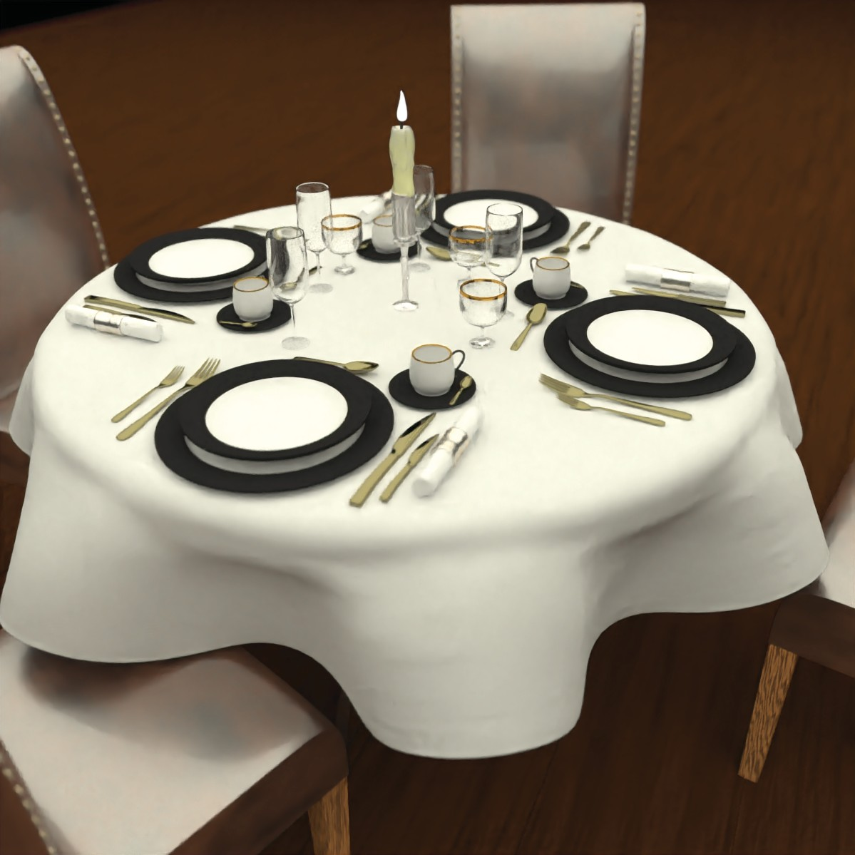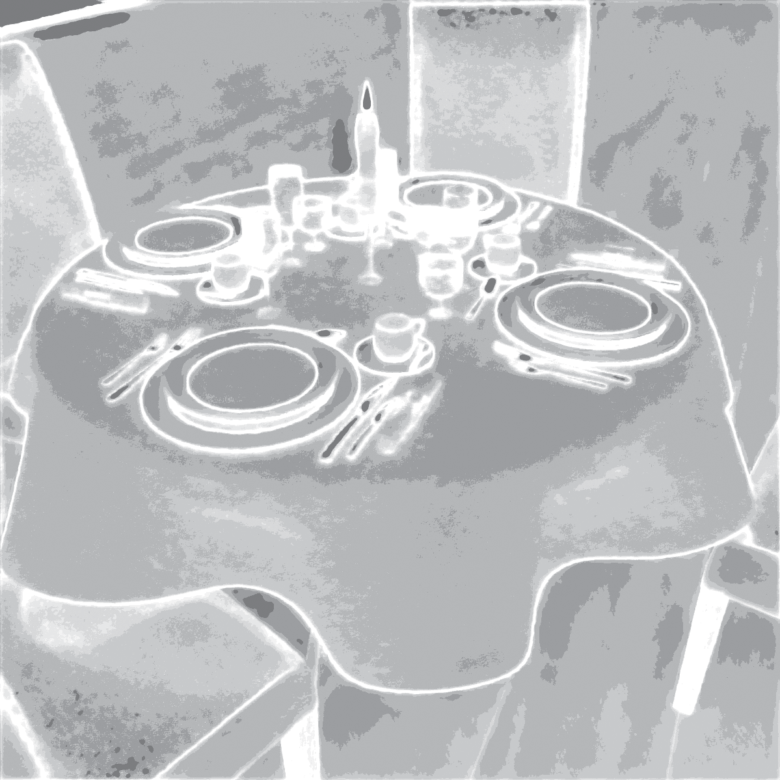

|  |  |  |  |  |
| --- | --- | --- | --- | --- |
|  |  |  |  |  |

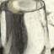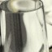

Dininu (Glass)

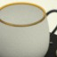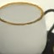

Low

|  |  |  |  |  |
| --- | --- | --- | --- | --- |
|  |  |  |  |  |

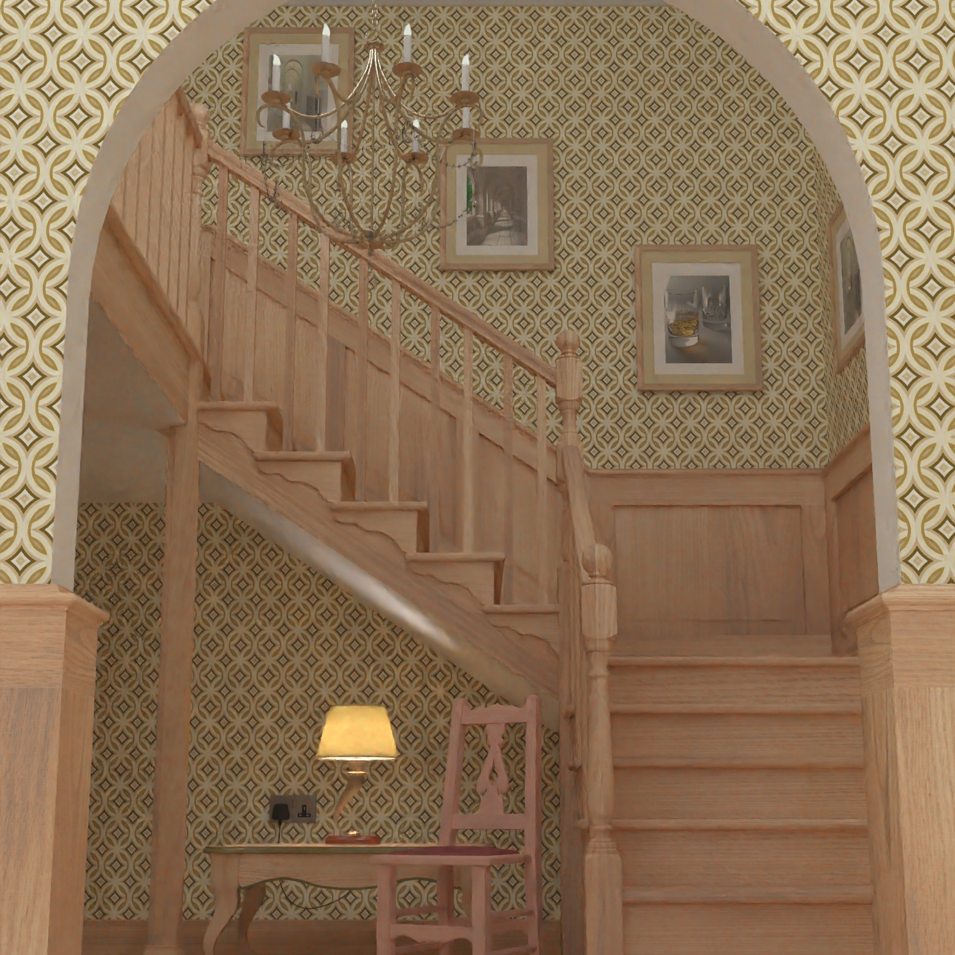

Stairyay (Global Illumination)

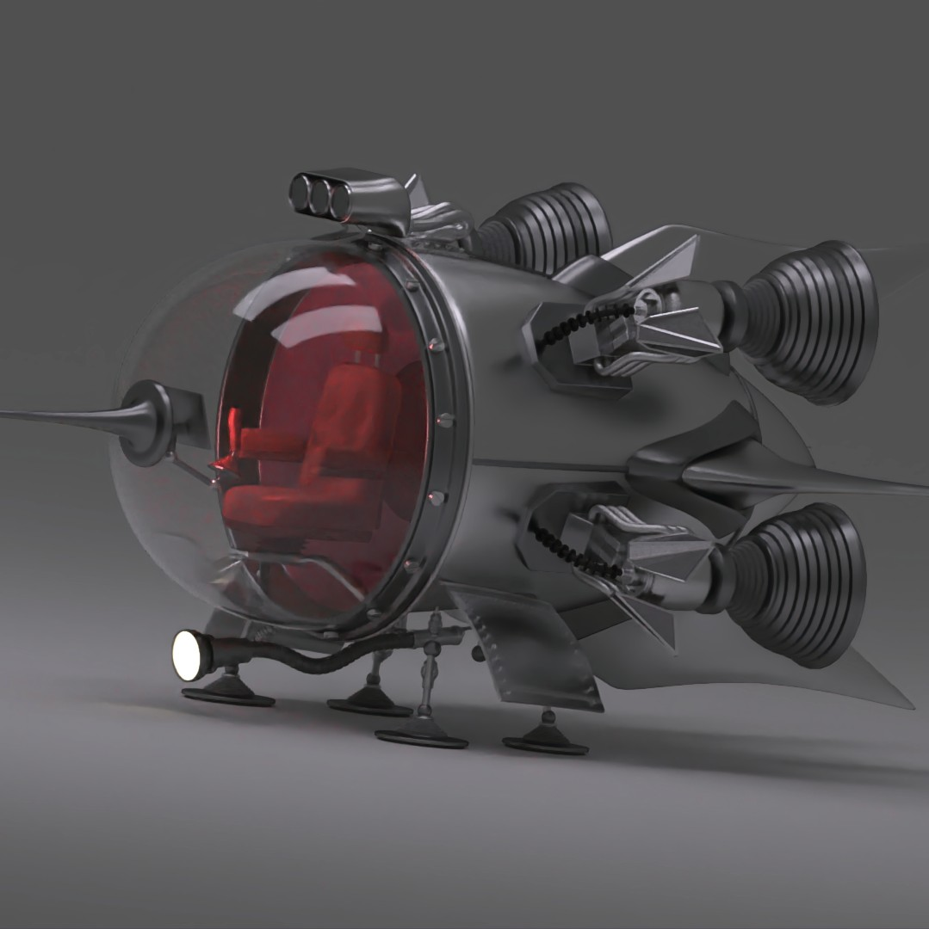

Spacesmip (Transparency)

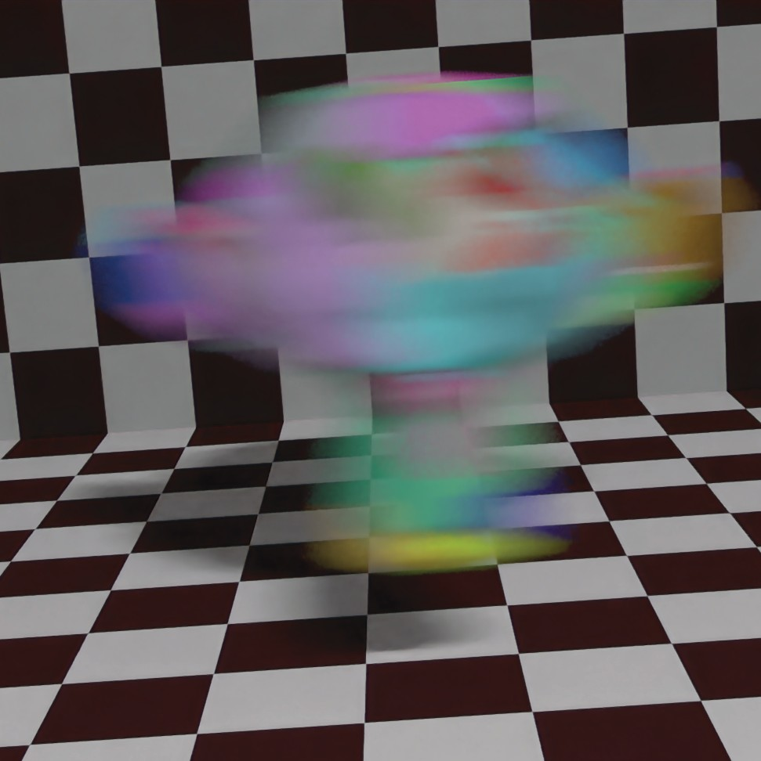

Monkey Head (Motion Blur)

9 spp

# 

|  |  |  |  |  |
| --- | --- | --- | --- | --- |
|  |  |  |  |  |

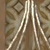

|  |  |  |  |  |
| --- | --- | --- | --- | --- |
|  |  |  |  |  |

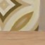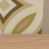

5 spp

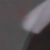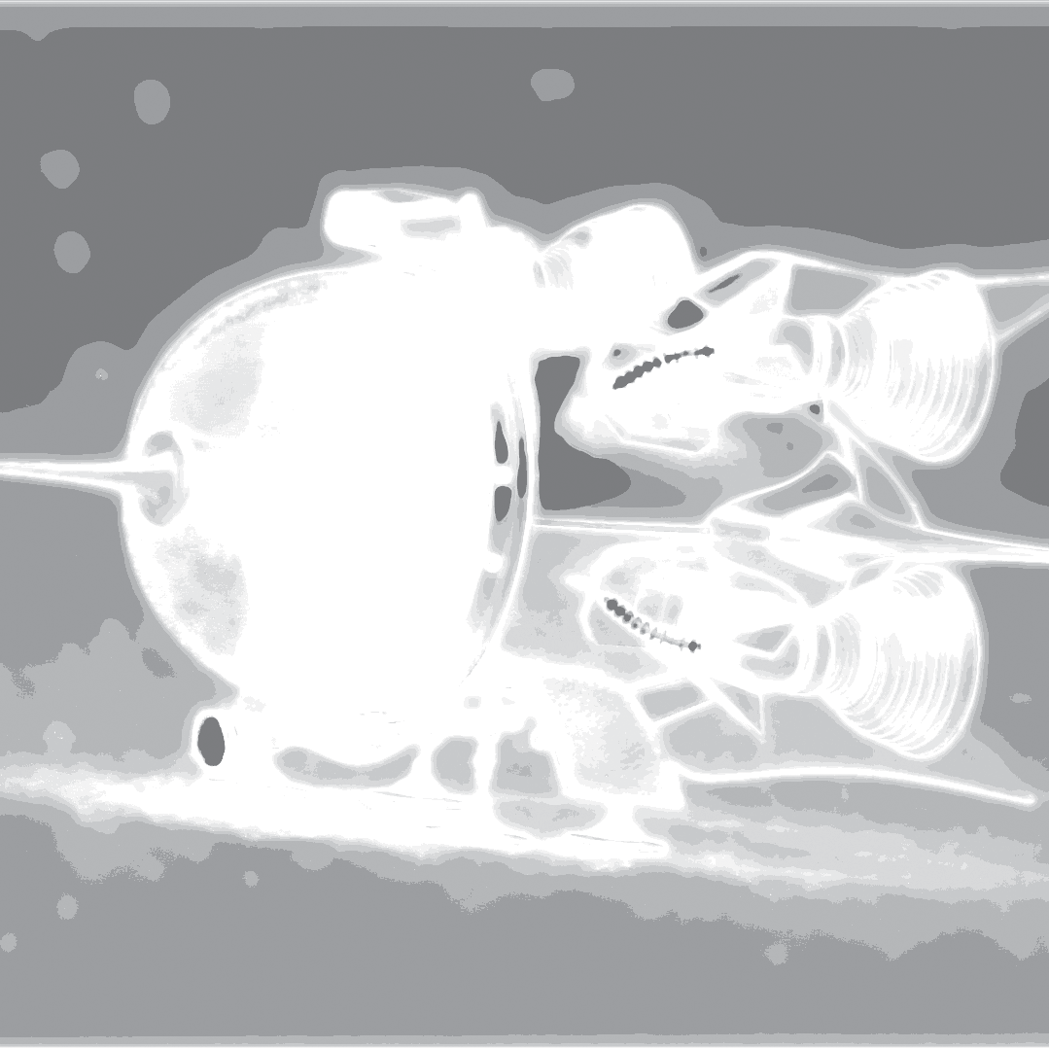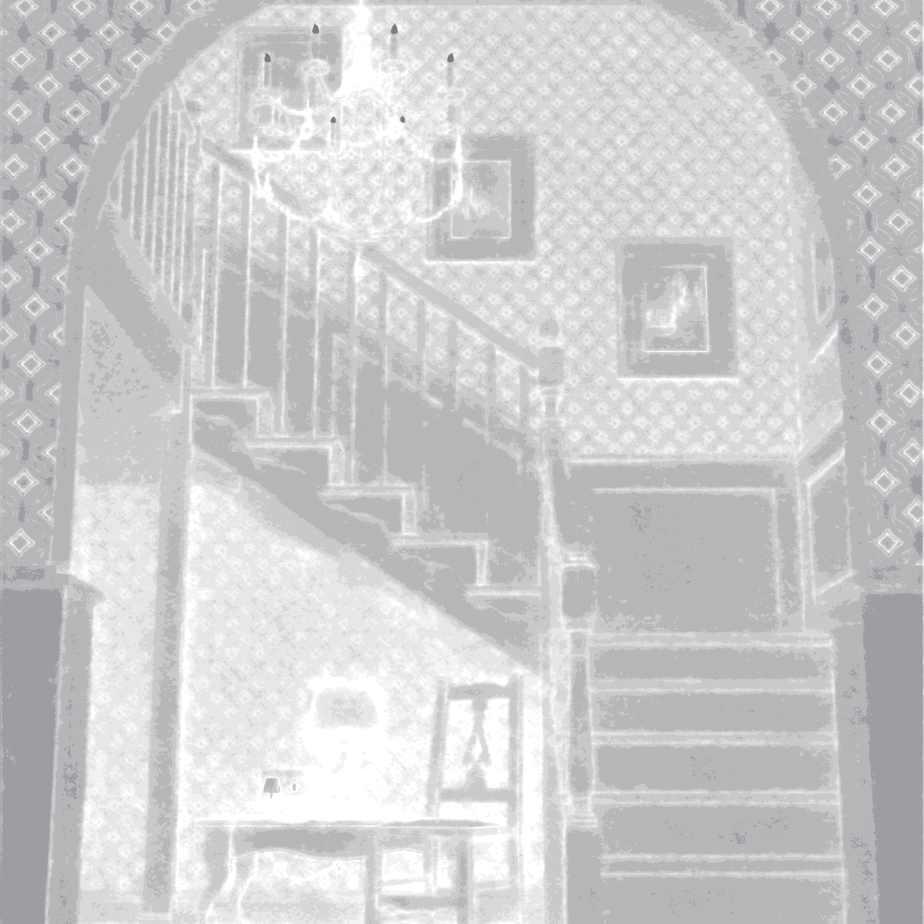

High

Low

High

# 

|  |  |  |  |  |
| --- | --- | --- | --- | --- |
|  |  |  |  |  |

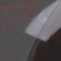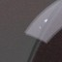

|  |  |  |  |  |
| --- | --- | --- | --- | --- |
|  |  |  |  |  |



16 spp

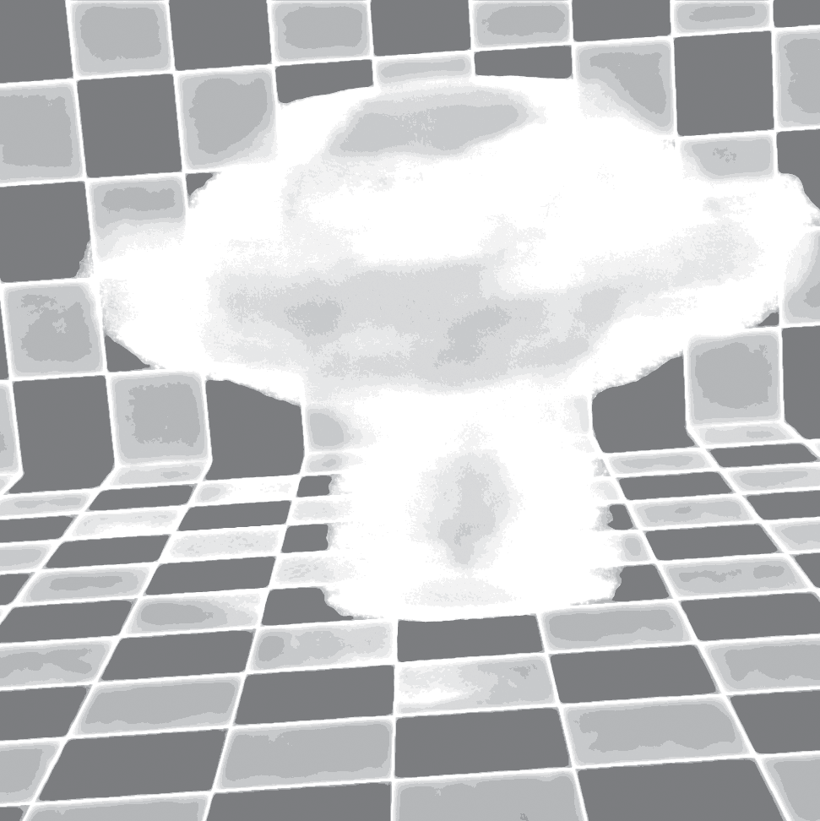

Low

High

# 

|  |  |  |  |  |
| --- | --- | --- | --- | --- |
|  |  |  |  |  |



|  |  |  |  |  |
| --- | --- | --- | --- | --- |
|  |  |  |  |  |

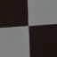

9 spp



Low

|  |  |  |  |  |
| --- | --- | --- | --- | --- |
|  |  |  |  |  |

# 

High

Low

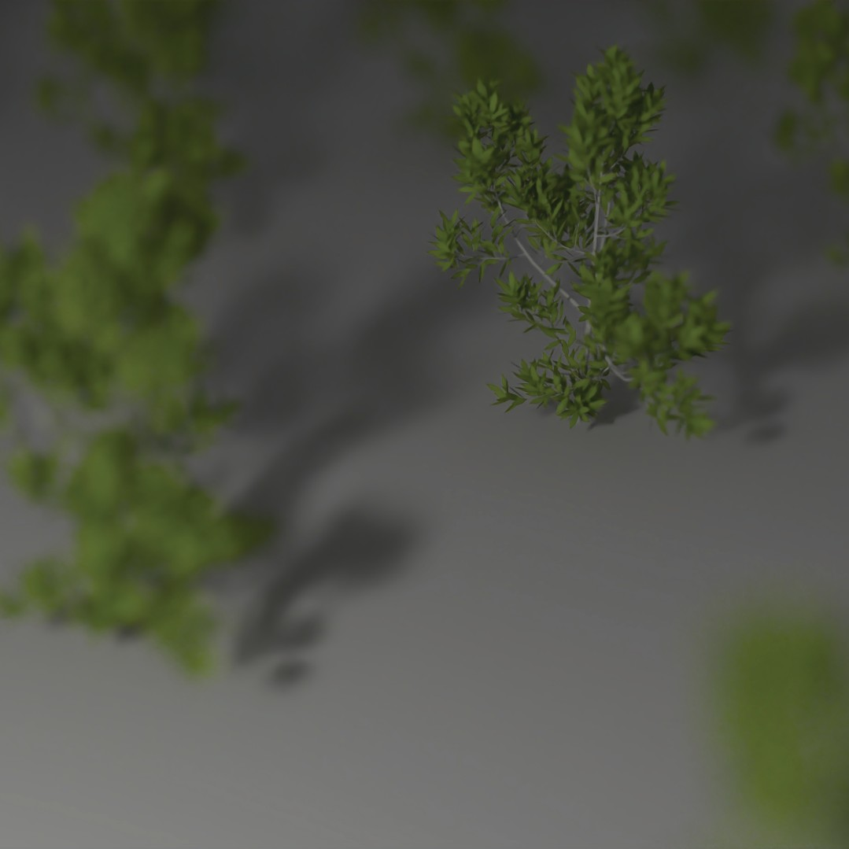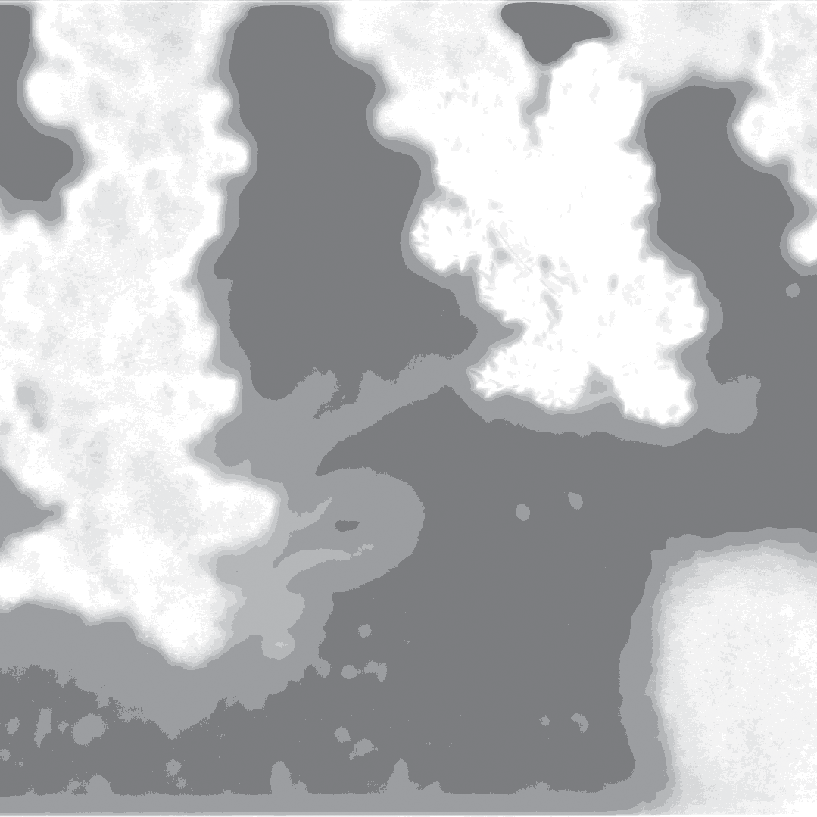

|  |  |  |  |  |
| --- | --- | --- | --- | --- |
|  |  |  |  |  |



Plants (Depth of Field)

5 spp

**Figure 7:** *Comparison of our approach against several other sampling techniques. The number of uniformly distributed samples required for obtaining the same quality as our approach with 4 spp is listed below the insets in the equal quality (EQ) column. For each scene, we show two insets from the high and low sampling density areas. In general, our method produces signiﬁcantly better results in the top green insets with high adaptive sampling rate, while doing as well as other approaches in the red bottom insets with low adaptive sampling rate. See numerical comparison on these images in Table 3.*

compared to the time required for rendering the input images with Blender’s Cycles raytracer (used in our implementation) or even GPU raytracers like Optix. Therefore, our approach provides a sig- niﬁcant speedup (50%) compared to uniform sampling, as this ap-

proach requires rendering 6 spp to achieve the same quality as ours. Note that, we report sampling counts rather than overall times to avoid referring to a particular system and implementation.

Variance

SURE

Ours

Our Filtered Result

0.01

0.009

0.008

rMSE

0.007

Variance

0.006 SURE

|  |  |  |  |
| --- | --- | --- | --- |
|  |  |  |  |

0.005

0.004

0.003

Uniform

Ours

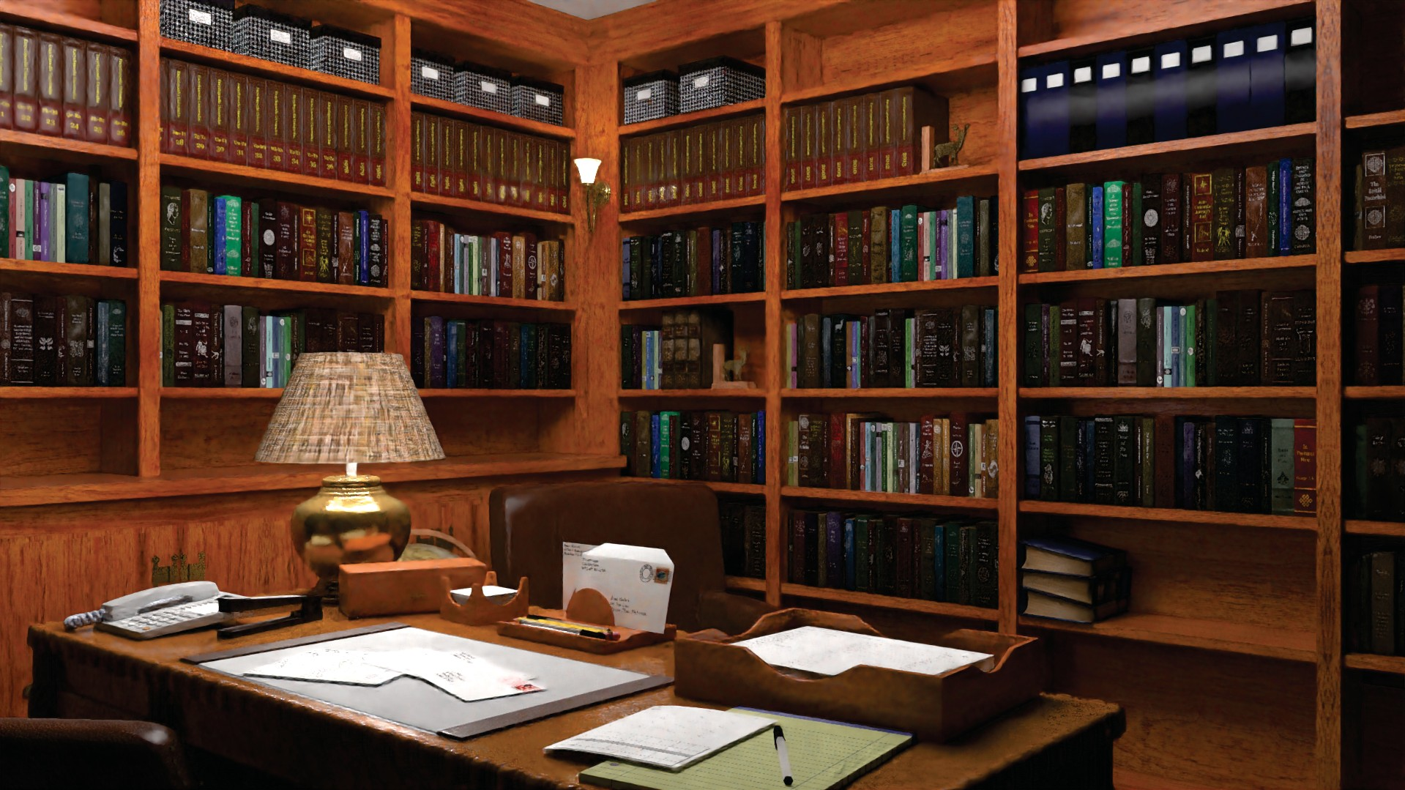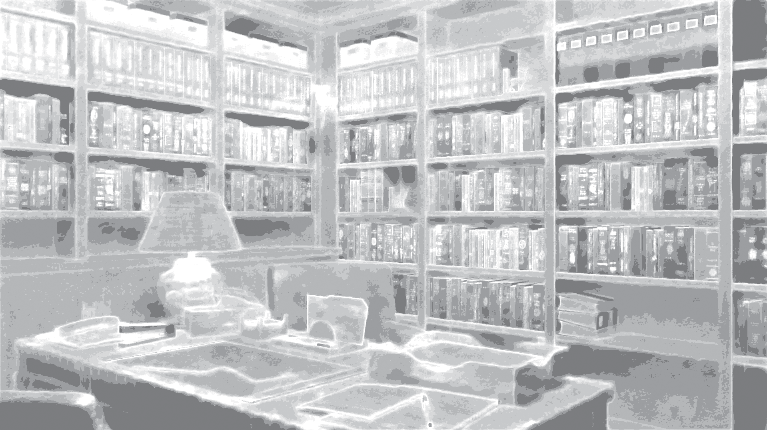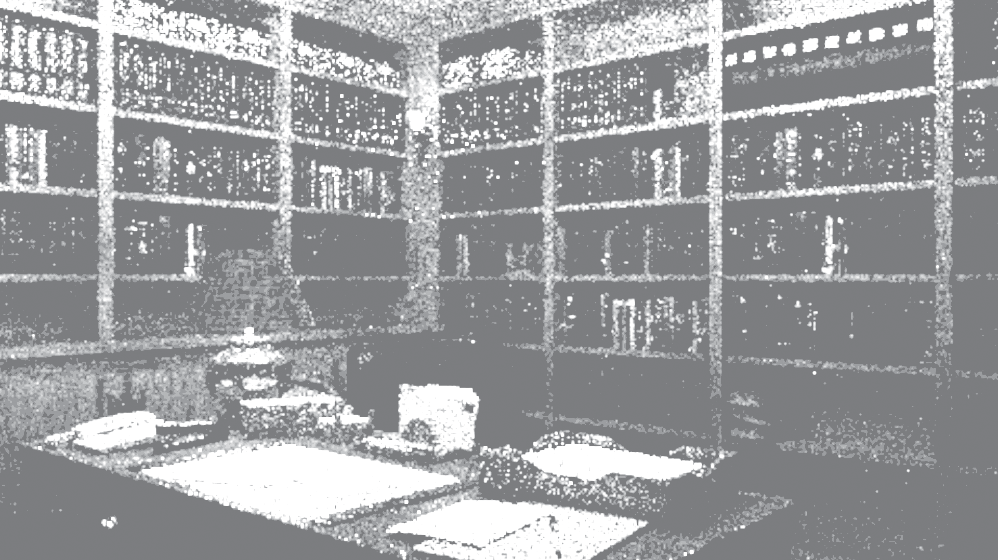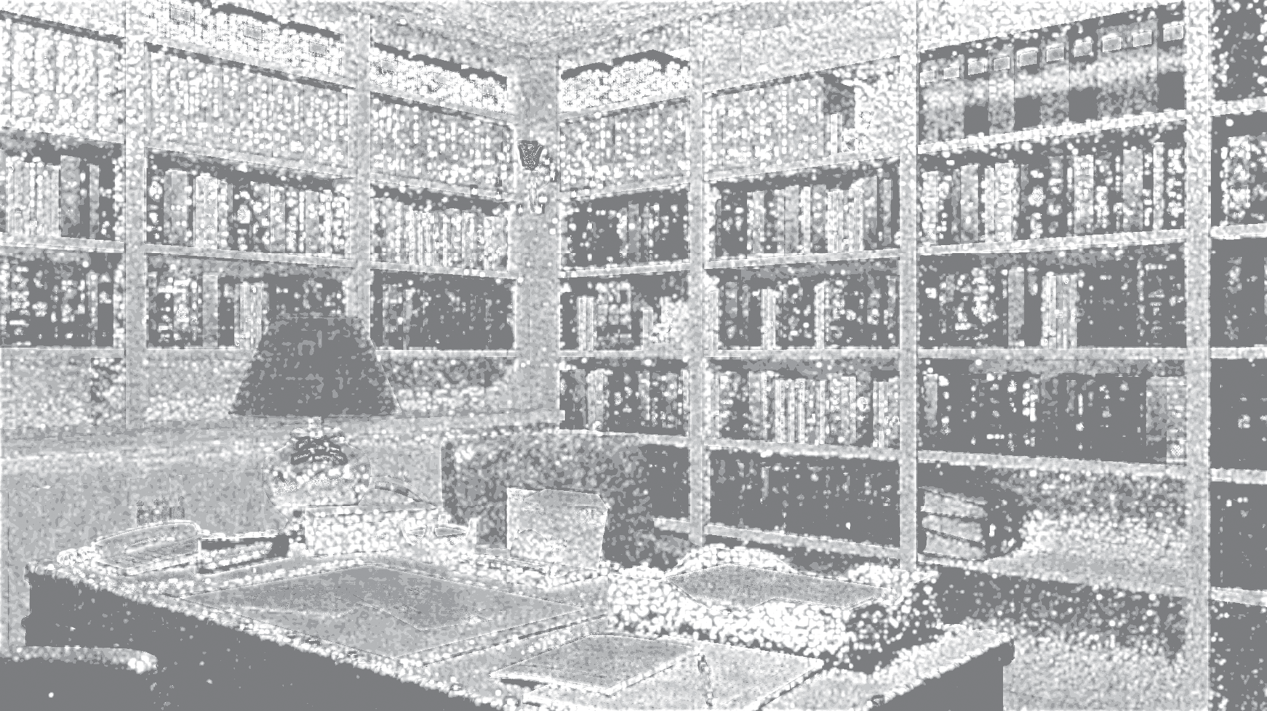

|  |  |  |
| --- | --- | --- |
|  |  |  |

**Figure 8:** *Comparison of sampling map against other techniques for different scenes.*

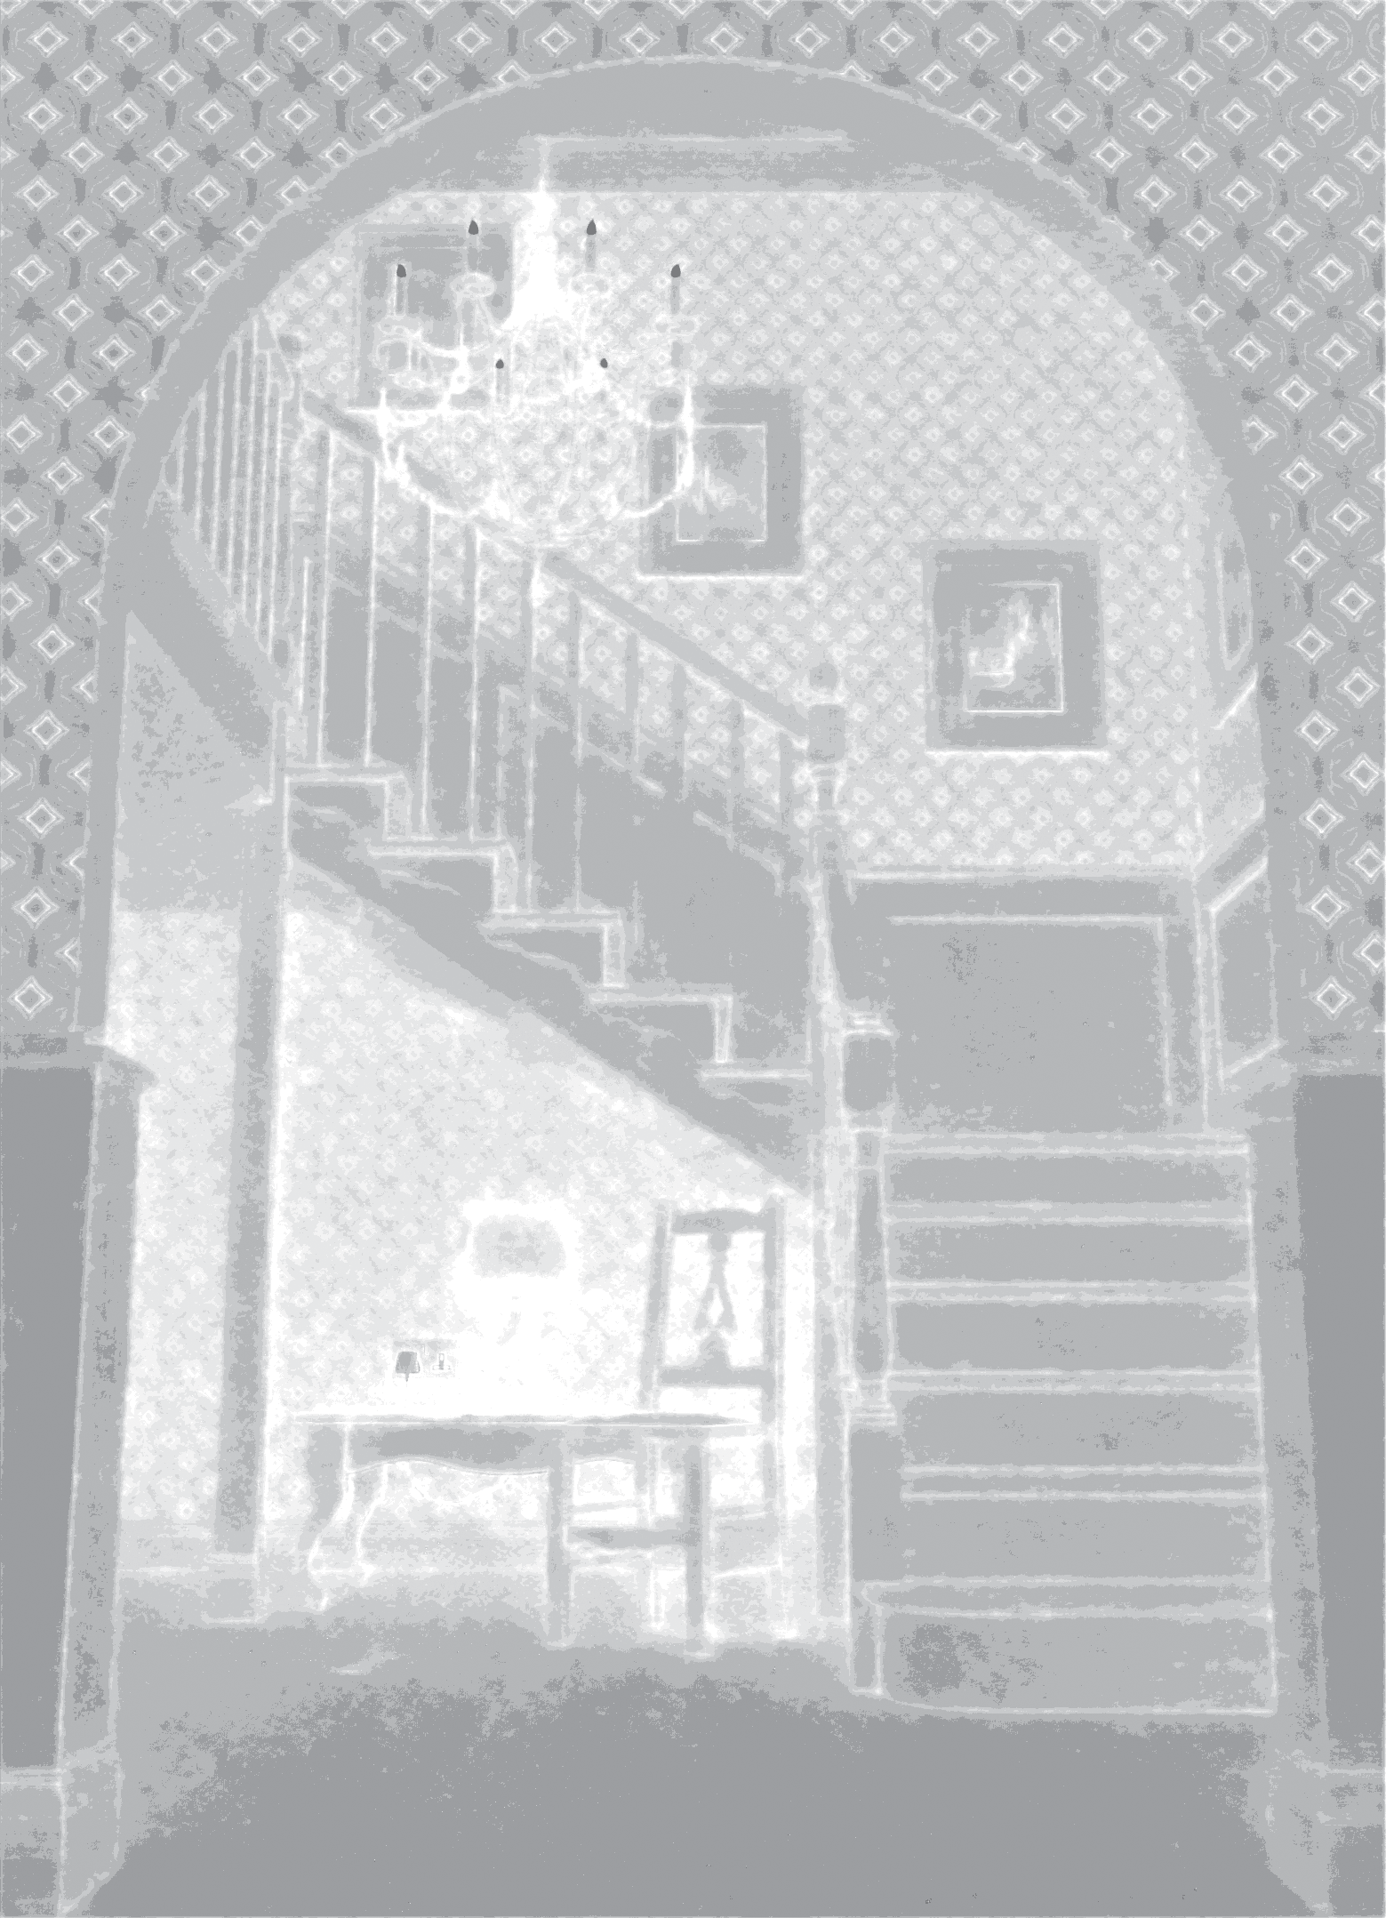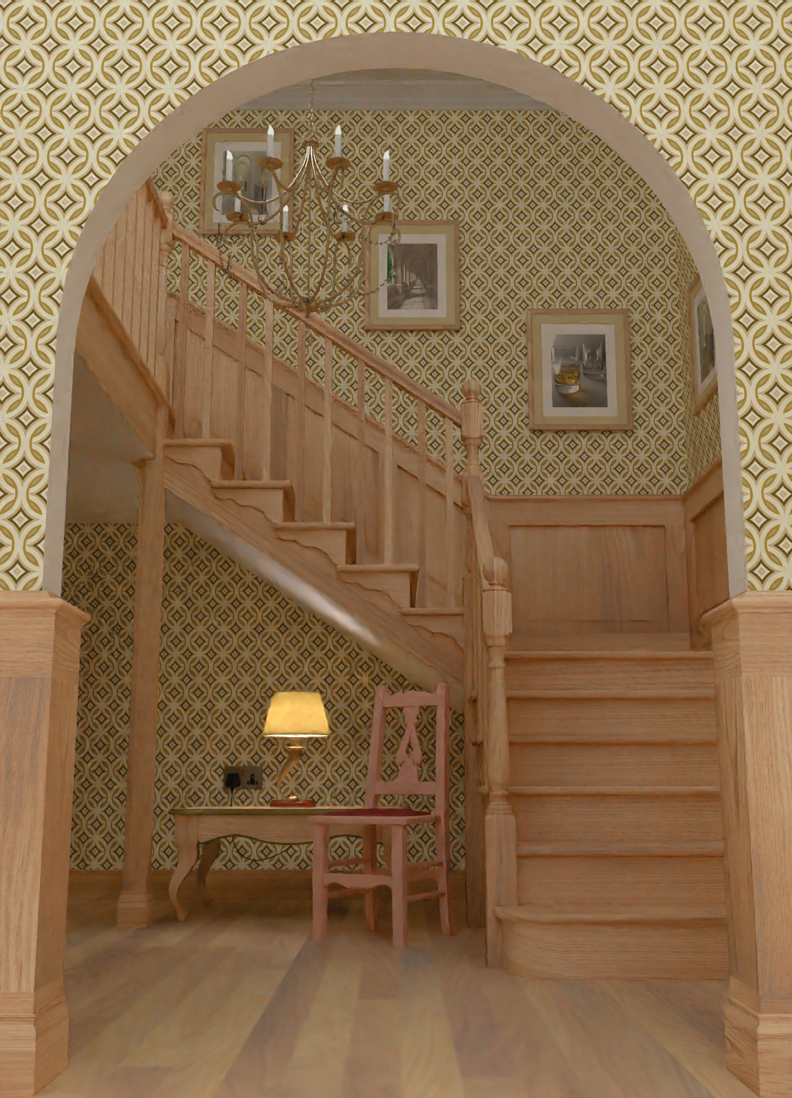

|  |  |  |  |
| --- | --- | --- | --- |
|  |  |  | 1 spp Input |
|  |  |  | Ground Truth |

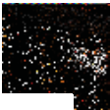

4 8 16 32 64 128

Average SPP

**Figure 10:** *Convergence analysis. The errors of Library scene with*

*respect to more samples for different methods after denoising.*

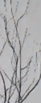

|  |  |  |  |
| --- | --- | --- | --- |
|  |  |  |  |

1 spp Sampling Map Our Result Ground Truth

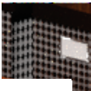

**Figure 11:** *Our sampling map cannot capture very thin structures such as some branches on this bush shown by the red arrow. How- ever, it still able to capture a branch 2 pixel wide shown by the green arrow.*

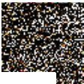

Variance

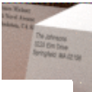

|  |  |  |  |
| --- | --- | --- | --- |
|  |  |  | 1 spp Input |
|  |  |  | Ground Truth |

SURE

Ours

cult for the denoiser, our approach does not produce signiﬁcantly better results than uniform sampling numerically, e.g., PLANTS scene in Fig. 7 (see Table 3). However, as discussed, our approach improves the visual quality of the results signiﬁcantly in the vast majority of examples.

Finally, our sampling map network is not able to properly sample the thin structures in noisy areas, as shown in Fig. 11. This is indeed a challenging case as the 1 spp input does not have sufﬁcient infor- mation for the sampling map network to detect the regions with thin structures.

**Figure 9:** *Comparison of sampling map against other techniques on the insets from Fig. 1.*

*Convergence Analysis –* For convergence analysis, we rendered multiple batches of 1 spp images. Then we generated the sampling map and rendered 3 additional adaptive samples as usual for each batch. After combining the batches into a single image (the total number of samples is four times the number of batches), we denoise the resulting image. Figure 10 shows how the error continues to decrease as we add more batches. Although our method continues to have the lowest error, the rate of convergence is slightly slower than one of the uniform method.

*Limitations –* In the cases where most regions are equally difﬁ-

## Conclusions and Future Work

We have presented a novel deep learning approach for joint adap- tive sampling and reconstruction of MC rendered images with low sampling counts. We use a convolutional neural network (CNN) to estimate a sampling map from a uniformly sampled 1 spp image. We then use the map to render three additional samples adaptively. Finally, we denoise the rendered image using another CNN to pro- duce the ﬁnal image. We train both networks on a set of scenes with different distributed effects in an end-to-end fashion. To the best of our knowledge, there are no existing adaptive sampling techniques for extremely low sample counts and the simple alternatives per- form signiﬁcantly worse than our approach and even uniform sam- pling. Our method is the ﬁrst learning-based approach that enables adaptive sampling in extremely low sample count MC rendering.

In the future, it would be interesting to use generative adversarial networks to improve the perceptual quality of the results. Moreover, we would like to investigate the possibility of performing joint sam- pling and denoising at multiple scales to be able to generate high- quality results at the rates lower than 1 sample per pixel. At the other extreme, we would like to investigate learning-based adaptive sampling for higher sample counts in production rendering. Even though standard adaptive sampling approaches can be applied for higher sample counts, there may still be advantages to a learning- based approach.

## Acknowledgements

This work was funded in part by NSF grant 1451830, Samsung, the Ronald L. Graham endowed Chair, and the UC San Diego Center for Visual Computing. We also acknowledge computing resources from NSF Chase-CI 1730158.

We also would like to thank the following authors for the scenes used in the paper: ThePefDispenser, Mikel007, Wig42, thecali, Greg Zaal, GJ2012, Ali Gonzalez, Jay-Artist and Bhavin Solanki.

## References

[BEEM15] BAUSZAT P., EISEMANN M., EISEMANN E., MAGNOR M.:

General and robust error estimation and reconstruction for monte carlo rendering. *Computer Graphics Forum (Proc. Eurographics) 34*, 2 (jan 2015). 2

[BEM11] BAUSZAT P., EISEMANN M., MAGNOR M.: Adaptive sam-

pling for geometry-aware reconstruction ﬁlters. In *Proc. Vision, Mod- eling and Visualization (VMV)* (Oct 2011), Eurographics, pp. 183–190. 3

[BM98] BOLIN M. R., MEYER G. W.: A perceptually based adaptive sampling algorithm. In *SIGGRAPH 98* (1998), pp. 299–309. 2

[BVM∗17] BAKO S., VOGELS T., MCWILLIAMS B., MEYER M., NOVÁK J., HARVILL A., SEN P., DEROSE T., ROUSSELLE F.: Kernel-

predicting convolutional networks for denoising monte carlo renderings.

*ACM TOG 36*, 4 (July 2017). 3

[CKS∗17] CHAITANYA C. R. A., KAPLANYAN A. S., SCHIED C., SALVI M., LEFOHN A., NOWROUZEZAHRAI D., AILA T.: Interactive

reconstruction of monte carlo image sequences using a recurrent denois- ing autoencoder. *ACM TOG 36*, 4 (July 2017), 98:1–98:12. 2, 3

[CPC84] COOK R., PORTER T., CARPENTER L.: Distributed Ray Trac- ing. In *SIGGRAPH 84* (1984), pp. 137–145. 2

[ETH∗09] EGAN K., TSENG Y., HOLZSCHUCH N., DURAND F., RA-

MAMOORTHI R.: Frequency analysis and sheared reconstruction for ren- dering motion blur. *ACM TOG 28*, 3 (2009). 2

[Guo98] GUO B.: Progressive radiance evaluation using directional co- herence maps. In *SIGGRAPH 98* (1998), pp. 255–266. 2

[HJW∗08] HACHISUKA T., JAROSZ W., WEISTROFFER R., DALE K.,

HUMPHREYS G., ZWICKER M., JENSEN H.: Multidimensional adap- tive sampling and reconstruction for ray tracing. *ACM TOG 27*, 3 (2008). 2

[Kaj86] KAJIYA J.: The Rendering Equation. In *SIGGRAPH 86* (1986), pp. 143–150. 2

[KB14] KINGMA D. P., BA J.: Adam: A method for stochastic optimiza- tion. *CoRR abs/1412.6980* (2014). 5

[KBS15] KALANTARI N., BAKO S., SEN P.: A machine learning ap- proach for ﬁltering monte carlo noise. *ACM TOG 34*, 4 (2015). 3

[KFF∗15] KELLER A., FASCIONE L., FAJARDO M., GEORGIEV I., CHRISTENSEN P., HANIKA J., NICHOLS G., EISENACHER C.: The

path-tracing revolution in the movie industry. SIGGRAPH 2015 Course Notes, 2015. 2

[KS13] KALANTARI N., SEN P.: Removing the noise in Monte Carlo rendering with general image denoising algorithms. *CGF 32*, 2 (2013). 2

[LRU85] LEE M., REDNER A., USELTON S.: Statistically optimized sampling for distributed ray tracing. In *SIGGRAPH 85* (1985), pp. 61– 68. 2, 3, 6

[LWC12] LI T., WU Y., CHUANG Y.: SURE-based optimization for adaptive sampling and reconstruction. *ACM TOG 31*, 6 (2012). 2, 3,

6

[MCY14] MOON B., CARR N., YOON S.: Adaptive rendering based on weighted local regression. *ACM TOG 33*, 5 (2014). 2

[MGYM15] MOON B., GUITIAN J., YOON S., MITCHELL K.: Adaptive

rendering with linear predictions. *ACM TOG 34*, 4 (2015). 2

[Mit87] MITCHELL D.: Generating antialiased images at low sampling densities. In *SIGGRAPH 87* (1987), pp. 65–72. 2

[Mit91] MITCHELL D.: Spectrally Optimal Sampling for Distribution Ray Tracing. In *SIGGRAPH 91* (1991), pp. 157–164. 2

[MMMG16] MOON B., MCDONAGH S., MITCHELL K., GROSS M.:

Adaptive polynomial rendering. *ACM TOG 35*, 4 (2016). 2

[MWR12] MEHTA S., WANG B., RAMAMOORTHI R.: Axis-aligned ﬁl-

tering for interactive sampled soft shadows. *ACM TOG 31*, 6 (2012). 3

[MYRD14] MEHTA S., YAO J., RAMAMOORTHI R., DURAND F.: Fac-

tored axis-aligned ﬁltering for rendering multiple distribution effects.

*ACM TOG 33*, 4 (2014). 3

[ODR09] OVERBECK R., DONNER C., RAMAMOORTHI R.: Adaptive

Wavelet Rendering. *ACM TOG 28*, 5 (2009). 2

[PGC∗17] PASZKE A., GROSS S., CHINTALA S., CHANAN G., YANG E., DEVITO Z., LIN Z., DESMAISON A., ANTIGA L., LERER A.: Au-

tomatic differentiation in pytorch. 6

[RB11] RAVISHANKAR S., BRESLER Y.: Mr image reconstruction from highly undersampled k-space data by dictionary learning. *IEEE Trans- actions on Medical Imaging 30*, 5 (May 2011), 1028–1041. 6

[RKZ11] ROUSSELLE F., KNAUS C., ZWICKER M.: Adaptive sampling

and reconstruction using greedy error minimization. *ACM TOG 30*, 6 (Dec. 2011), 159:1–159:12. 2

[RKZ12] ROUSSELLE F., KNAUS C., ZWICKER M.: Adaptive rendering

with non-local means ﬁltering. *ACM TOG 31*, 6 (Nov. 2012), 195:1–

195:11. 2

[RMZ13] ROUSSELLE F., MANZI M., ZWICKER M.: Robust denoising

using feature and color information. *CGF 32*, 7 (2013), 121–130. 2 [SKW∗17] SCHIED C., KAPLANYAN A., WYMAN C., PATNEY A.,

CHAITANYA C. R. A., BURGESS J., LIU S., DACHSBACHER C.,

LEFOHN A., SALVI M.: Spatiotemporal variance-guided ﬁltering: Real- time reconstruction for path-traced global illumination. In *HPG* (2017),

ACM, pp. 2:1–2:12. 2

[SSD∗09] SOLER C., SUBR K., DURAND F., HOLZSCHUCH N., SIL-

LION F.: Fourier depth of ﬁeld. *ACM TOG 28*, 2 (2009). 2

[WYKR17] WU L., YAN L., KUZNETSOV A., RAMAMOORTHI R.:

Multiple axis-aligned ﬁlters for rendering of combined distribution ef- fects. *CGF 36*, 4 (2017), 155–166. 3

[YMRD15] YAN L., MEHTA S., RAMAMOORTHI R., DURAND F.: Fast

4D sheared ﬁltering for interactive rendering of distribution effects. *ACM TOG 35*, 1 (2015). 3

[ZJL∗15] ZWICKER M., JAROSZ W., LEHTINEN J., MOON B., RA- MAMOORTHI R., ROUSSELLE F., SEN P., SOLER C., YOON S.: Re-

cent advances in adaptive sampling and reconstruction for monte carlo rendering. *Computer Graphics Forum (EUROGRAPHICS STAR 2015) 34*, 2 (2015), 667–681. 2